Unit Dog
Step 1: Build a dog using 13 cubes as shown below. 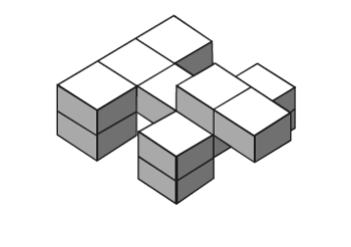
Step 2: 1. What is the surface area of the dog?
2. What is the volume of the dog?
Step 3: Draw the following views/perspectives of the dog:
Front: Side/lateral: Top/aerial:

Step 4: On a piece of grid paper, draw a net for the dog. You can draw separate nets for the legs, head, and body. (attach the grid paper to this assignment)
Step 5: Choose one of the following to construct: a double dog, a triple dog, a quadruple dog, a half dog. You must double/triple/quadruple/half every dimension.
Step 6: 3. What is the surface area of your new dog?
4. What is the volume of your new dog?
Step 7: Make a net for your new dog. Cut this net out and actually construct a paper dog.

Step 8: Complete the chart below:

Dimensions increased by a factor of… | Surface area of dog | Area increased by a factor of.. | Volume of dog | Volume increased by a factor of…
1
2
3
4
5
10

Step 9: Answer the following questions using what you have learned:

