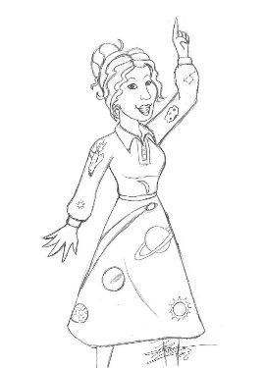
TV Teacher Trivia Graphing and Statistics

- Take the quiz and grade
- Class Tally
Mean:

Median:

Mode:

Range:
Score | Tally | Percent of class scoring this number
5
10
15
20
25
30
35
40
45
50
55
60
65
70
75
80
85
90
95
100

- Find the variance of this data:
- Find the standard deviation of this data:
- Make a stem and leaf plot representing this data:

- What is:

  - the lower quartile:
  - The upper quartile:
  - Interquartile range:
- Draw a box and whisker plot of this data:

- Create a horizontal bar graph of this data:
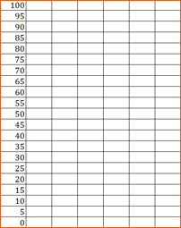
- Is the data normally distributed, skewed left (negatively skewed) or skewed right (positively skewed)?

- Create a circle graph of our data:

