Name_______________
Scholars Snack Mix
Recipe for Scholars Snack Mix:
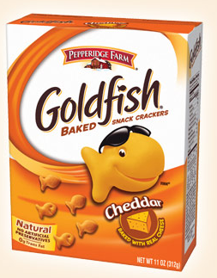
½ cup of cheerios
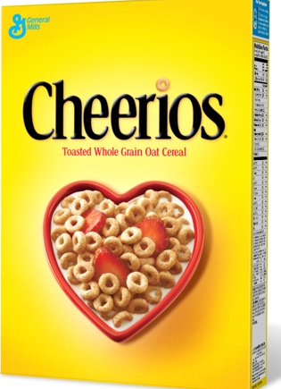
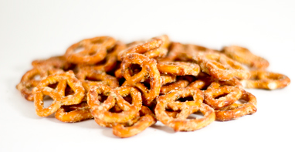
2/3 cup of goldfish
¼ cup of marshmallows
¾ cup of pretzels

STEP ONE: Measure all your ingredients into a bowl.
STEP TWO: List the ingredients in order from the one that you have the least of to the one that you have the greatest amount of. You will first need to find equivalent fractions so that all the ingredients have a common denominator.

STEP THREE: How many cups of snack mix do you make if you follow this original recipe? Use the picture below to help you. Shade in the amount you will need of each ingredient.
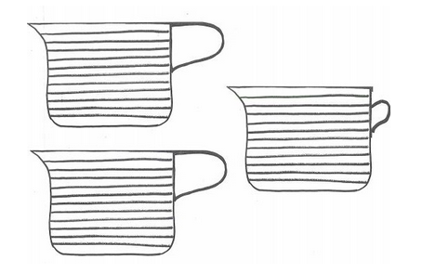

STEP FOUR: How much more pretzels do you have than goldfish?

STEP FIVE: It’s time to DOUBLE THE RECIPE. Write how much of each ingredient you would need if you wanted to make twice as much snack mix.

______ cup of cheerios
______cups of goldfish
______cup of raisins
______cups of pretzels

TOTAL CUPS OF SNACK MIX:

STEP SIX: You need to share the snack mix equally, so that each member of your group gets the same amount. How would you do this? How much would each person get?
_____________________________________________________________________________________________________________________________________________________________________________________________________________________________________________________________________________________________________________________________________________________________________________________________________________________

STEP EIGHT: TIME TO EAT!

CHALLENGE: What if you needed to make enough Scholars Snack Mix for the entire school? What information would you need to know in order to figure out how much you need of each ingredient?

