Field Notes and Reflection Prompts 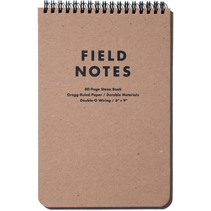
As you experience your summer research, the goal is for you to reflect on what it means to be a scientist, how scientists work, what it means to be a science teacher, and how you can best cultivate scientific inquiry skills in your classroom. You can complete some of the field notes while you are doing the science, and shortly afterward, reflect on what you did and what you learned. These are important data that will help others translate these experiences to classrooms. YOU are part of a MODEL that will be created. Your thoughtfulness is important, your creativity is valued, your opinions matter and most importantly, your honest and forthright expressions of your thoughts will help articulate what worked well and what could be improved. Your writing is important!! Please be thoughtful.
The science you do and experience is reported in a direct and unbiased fashion through your observations, data collections and summaries of what you did. Your reflections, however, are YOURS. Here are some questions you may consider:
My Experience:
- What did I learn about the nature of science through my field experience today?
- What am I seeing and experiencing that challenge ideas that I previously held regarding how scientists work and discover new things?
- How is the way I am doing science this summer different than how science is taught in the classroom?
- How can I create experiences for my students that more closely reflect how real scientists work?
- What new ideas do I have regarding classroom curriculum and how I can incorporate authentic science in that curriculum?
The Science I’m Doing:
- What is the significance of the project that I am involved in?
- What kind of hypothesis did the research begin with? Has the hypotheses been supported, refuted or modified based on evidence from the research? How?
- What kind of obstacles has the scientists encountered in conducting research? How have these obstacles been addressed?
- Are there things about the process that the scientists go through or the results themselves that have surprised me?
Food for Scientific Thought:
- Based on my reflection, what questions do I need to ask my science faculty researcher?
- What connections did I see between math and science during my experience?

