Super STAAR Review Stations
Station One: Estimation

Kyle set up a bike race that was 42 miles long and 7,692 people participated in the race. About how many miles were biked in total?

- $3,200
- $32,000
- $320,000
- $3,200,000

Station Two: Measurement Conversion

Jacobi’s father drives a truck 4 days each week. The table shows the driving record for one week.

Day | Distance Traveled
Monday | 30.51 km
Tuesday | 105.4 km
Wednesday | 80.75 km
Thursday | 64.6 km

What is the total number of meters Jacobi’s father drove? Show your work and answer below.

Station Three: Adding and Subtracting Fractions

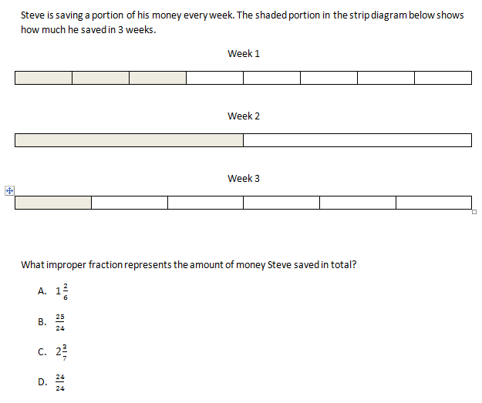
Station Four: Perimeter and Area

What is the perimeter of the paper after you fold it? Use the griddable to mark your answer.

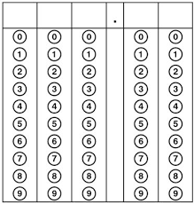
Station Five: Volume

- How many unit cubes are currently in the box?__________
- What is the total volume of the box?______________
- Explain how you got your answer: _______________________________________________________________________________________________________________________________________________________________________________________________________________

