Period of rotation: 59 days  Period of revolution: 88 days  Distance from Sun: 0.39 AU  Number of moons: 0  Atmosphere: None  Surface:  - Impact craters cover the surface.  - There are smooth plains of solidified lava.  - There is no erosion due to no atmosphere, so the formations have not changed. | 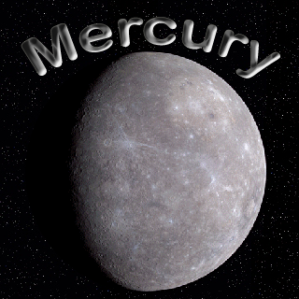
Period of rotation: 244 days  Period of revolution: 225 days  Distance from Sun: 0.72 AU  Number of moons: 0  Atmosphere:  - 97% Carbon Dioxide  - 90 times greater than Earth’s  - Has a think layer of acid clouds  Surface:  - 80% covered by solidified lava  - Radar shows volcanoes on the surface | 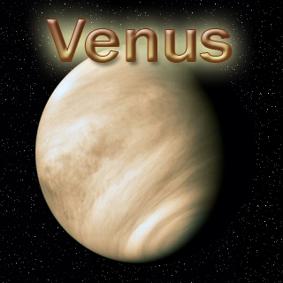
Period of rotation: 24 hours  Period of revolution: 365 days  Distance from Sun: 1.00 AU  Number of moons: 1  Atmosphere:  - Has a mixture of gases  - Greenhouse effect increases surface temperature  - Absorbs Sun’s radiation  Surface:  - Only planet with liquid water  - Moderate temperatures and water supports life | 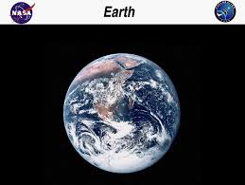
Period of rotation: 24.6 hours  Period of revolution: 1.88 years  Distance from Sun: 1.52 AU  Number of moons: 2  Atmosphere:  - 95% carbon dioxide  - Very thin  - Winds create dust storms  Surface:  - Reddish due to soil containing iron oxide  - Holds the largest known mountain  - Has Polar Ice Caps of frozen carbon dioxide and water | 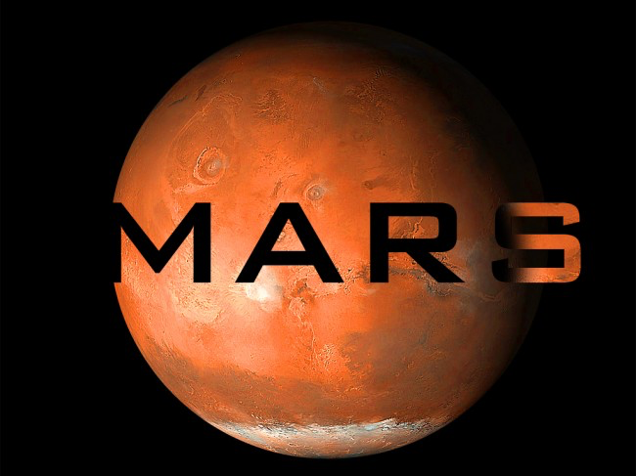
Period of rotation: 9.9 hours  Period of revolution: 11.9 years  Distance from Sun: 5.20 AU  Number of moons: 67  Atmosphere:  - 90% hydrogen 10% helium  - Has layers of dense colorful clouds  - Has the Great Red Spot  Surface:  - Outer layer is gas and inner layer is liquid  - Due to fast rotations, clouds look like bands around planet | 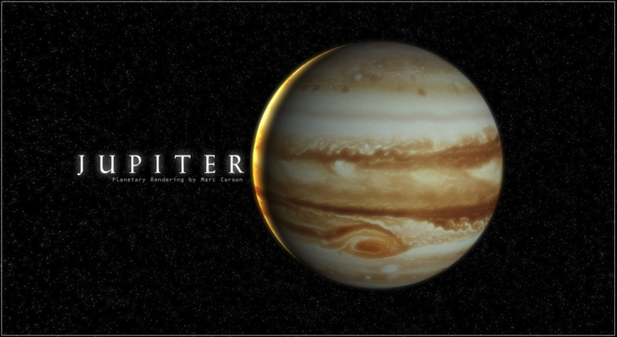
Period of rotation: 10.6 hours  Period of revolution: 29.7 years  Distance from Sun: 9.6 AU  Number of moons: 60  Atmosphere:  - Made of mostly hydrogen and helium  - Has a ring system made of particles of ice  Surface:  - Outer gas layer, liquid inner layer, and a solid core | 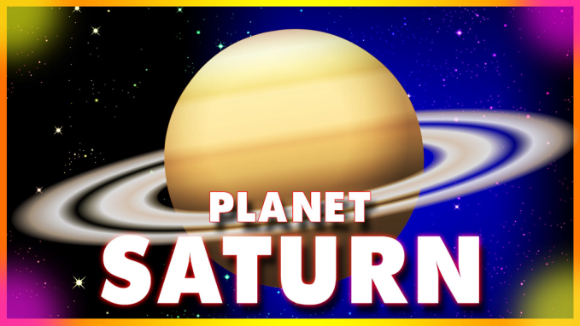
Period of rotation: 17.4 hours  Period of revolution: 84.3 years  Distance from Sun: 19.2 AU  Number of moons: 27  Atmosphere:  - Mostly hydrogen and helium  - Small amount of methane  - There are narrow dark rings  Surface:  - Thick slushy layer of water, and ammonia  - Might have solid core | 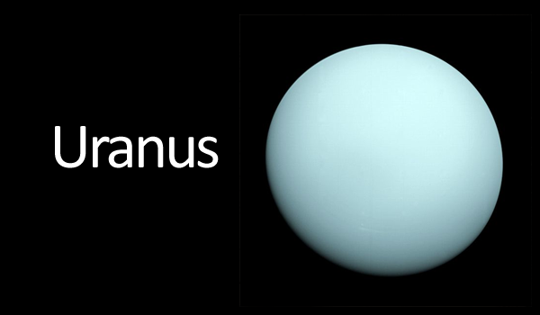
Period of rotation: 16.1 hours  Period of revolution: 165.2 years  Distance from Sun: 30.1 AU  Number of moons: 13  Atmosphere:  - Mostly hydrogen helium  - Traces of methane  - Faint dark rings  Surface:  - Partially frozen water and ammonia with solid core | 