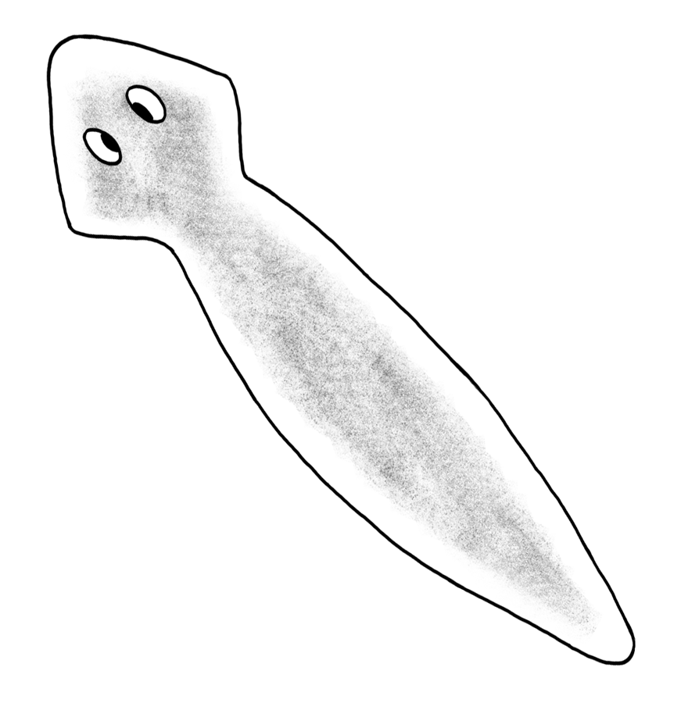

Planarian Behavior Lab
NAME ______________________________
In today’s lab, we will observe the behavior of planarians. Planarians are also called flatworms. They are simple organisms that have an eyespot and can detect light and dark. They also can sense chemicals like food. Let’s do an activity and see what planarians do. Your instructors have placed containers in the room with 6 planarians in each.
Initial Observations
Below, describe how the planarians are spaced in the container. Are they close together or spread out? You can draw a picture of where the planaria are located in the container.

EXPERIMENT One: A Little Shade
Now, cover ½ of the container with a piece of black fabric. We will wait a few minutes and see how the planarians respond when provided shade.
- Next to the word ‘hypothesis,’ write down what you think will happen to the planarians. Where will they go? Why?
Hypothesis – When the piece of black fabric is placed over the container, the planaria will________
_________________________________________________________________________________.

- Observations after 5 minutes: As before, write down where the planarians are. Did they stay in the light or move into the dark? How many moved? It is fine to draw a picture to help in your description.

- Conclusion: What did you learn about planaria from this experiment?

EXPERIMENT TWO: A Little Food 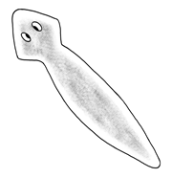
Add a small piece of liver to the left side of the container .
What do you expect to happen now? Will the planarians move? Write down your prediction by the word ‘hypothesis’ below.
- Hypothesis – When the liver is placed in the container, the planaria will______________________
_________________________________________________________________________________

- Now, observe the planarians after 5 minutes. Again, record their position and use a drawing to aid in your description of where they are.

- Conclusion: What did you learn about planaria from this experiment?

LEARNED BEHAVIOR OR INSTINCT?
- Do you think the planaria’s reaction to light is a learned behavior or an inherited one?

- Do you think the planaria’s reaction to liver is a learn behavior or an inherited one?

