Oh Deer Quiz
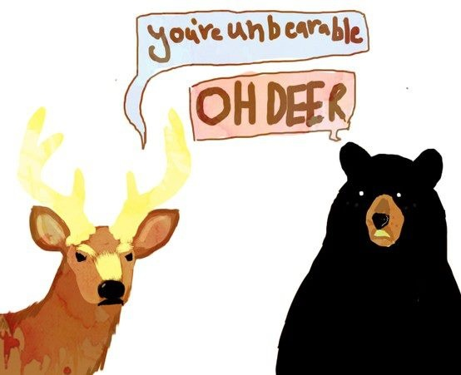

- In the game we played, did the deer population rise or decline when there was a large amount of resources? Why?

2. In the documentary about the wolves of Yellowstone, why did they say the wolf population is declining?

3. Define habitat. Give an example of a population and their habitat that we can find right here in Corpus Christi.

4. What are some factors other than water, food, and shelter that affect populations?

5. Define and give an example of a limiting factor we can find in nature.

