Oh Deer: Resources Needed 5E Lesson Plan
Teachers: Ms. Baumgartner, Ms. Dion, Ms. Guillory, Ms.Solis, Ms. Scherer, Ms. Vasquez
Date: March 24, 2016 (STEM Thursday)
Subject / grade level: 8th Grade Science – Resources within Ecosystems
Materials:

Per Student:
- Student activity sheet with graph and guiding questions
- Oh Deer quiz

Vocabulary:
- carrying capacity: the maximum population size of the species that the environment can sustain, given the food, habitat, water and other necessities available in the environment.
- limiting factors: a factor that controls an organism’s population, size, or distribution
- habitat: the natural environment in which an organism lives
TEKS: 11) Organisms and environments. The student knows that interdependence occurs among living systems and the environment and that human activities can affect these systems. The student is expected to:

(B) investigate how organisms and populations in an ecosystem depend on and may compete for biotic and abiotic factors such as quantity of light, water, range of temperatures, or soil composition;

ENGAGE
·
This documentary will be shown the day prior to the rest of the lesson. This is a documentary on the wolves of Yellowstone, and how the decline in resources has affected them over the years.

http://www.pbs.org/wnet/nature/in-the-valley-of-the-wolves-video-full-episode/4678/

Probing/Eliciting Questions:
- Why is the wolf population declining?
- How do wolves communicate?
- How do scientists track the wolves?
EXPLORE
- The students will play the game Oh Deer in order to understand how the rise and decline of resources affects animal populations in nature. (The game will be played outside)

https://naturebridge.org/sites/default/files/Oh%20Deer_1.pdf

2. Students will plot a double line graph based on the numbers of deer and resources at each part in the game. They will plot the time (determined by number of rounds) on the x axis and both the deer population and resources on the y-axis. The two variables will be in different colors. This will help them visually see how resources and populations are linked.

Probing/Eliciting Questions:
- Explain what this line graph tells us is the relationship between the number of deer and the number of resources available to them?
- What was the carrying capacity of the population of deer based on the findings from your graph?
- What would/did happen when there are no more resources? What would/did happen when there are no more deer?
EXPLAIN

- Students will explain in groups their findings from the graph.

Probing/Eliciting Questions:
- What do animals need to survive?
- What are some of the limiting factors?
- Do populations remain the same or change?

ELABORATE

- Students will be asked to write about what happened and why to the deer population when resources were abundant and when resources were in low supply.
·
Probing/Eliciting Questions:

- What are other factors that might affect the deer population? (Examples include disease, dramatic weather changes, habitat destruction, elimination or introduction of predators, pollution, the introduction of competing species, etc.)

EVALUATE

- Students will receive a quiz to be evaluated on their understanding of how organisms and populations in an ecosystem depend on resources such as water, food, and shelter in order to survive.

Oh Deer Quiz

Probing/Eliciting Questions:
- In the game, did the deer population rise or decline when there was a large amount of resources? Why?
- In the documentary about the wolves of Yellowstone, why did they say the wolf population is declining?
- Define habitat. Give an example of a population and their habitat that we can find right here in Corpus Christi.

Closure Statement: Today, we learned about the relationship between a population and the resources available to it. Thank you for letting us come in today and teach you!

Oh Deer! What Happened? (Student Handout)

Round | 1 | 2 | 3 | 4 | 5 | 6 | 7 | 8 | 9 | 10
Deer
Resources

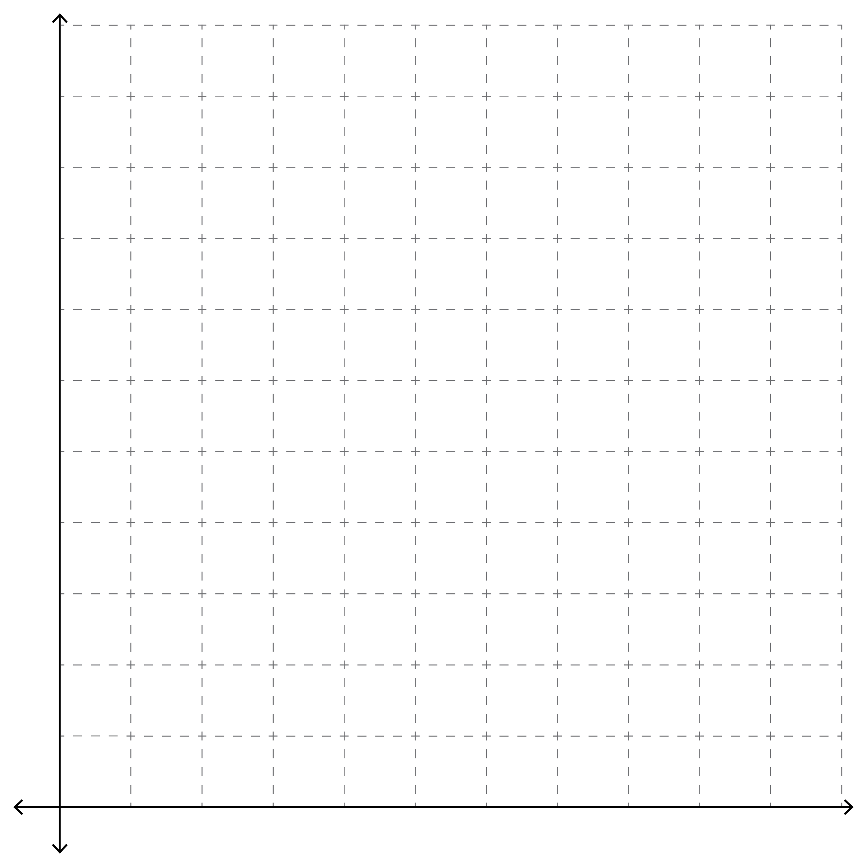
Directions for Graph: Label your x-axis number as time and your y-axis number of deer and resources. You will be making a double line graph. Use one color for number of deer left after each round and a different color for the number of resources.

After you graph your data answer the following questions.

1.What did you notice about the deer population in relation to the resources during the game?

2.What happened as the deer population increased? What happened when the resources decreased?

3.What did you learn about natural selection from the video you watched? How did this relate to what you learned from playing the game Oh Deer?

4.What are some aspects that affected the populations of the elk in the video? What about the wolves?

5.What are some other examples of natural selection you can think of in addition to the deer population or the elk/ wolf populations already mentioned?

