digestion | the process by which food is broken down into substances that can be used by the cells of the body | 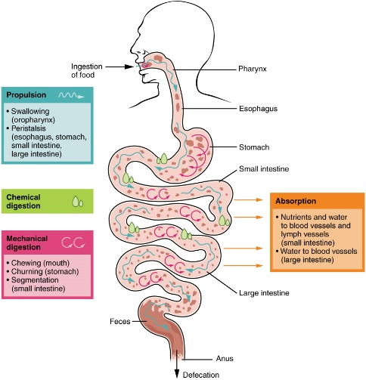
mechanical digestion | this occurs as the food is broken down into smaller pieces | 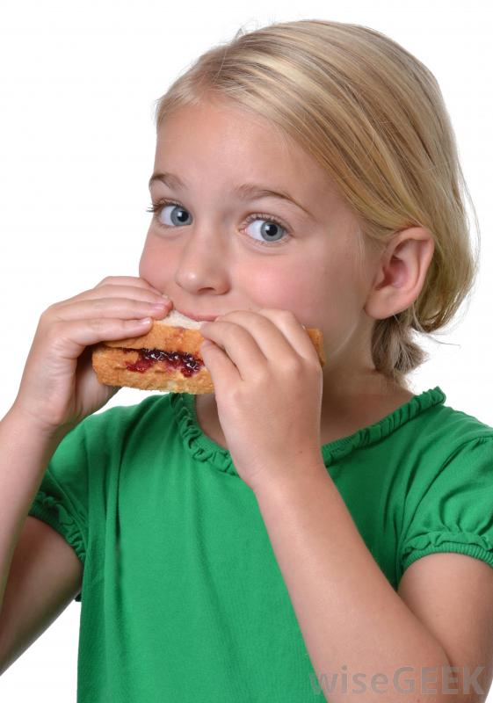
chemical digestion | the process by which foods are chemically changed into simpler substances | 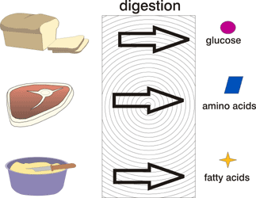

enzyme | a protein substance that speeds up chemical reactions and breaks down large molecules into small molecules
peristalsis | the squeezing motion that pushes food through the digestive system | 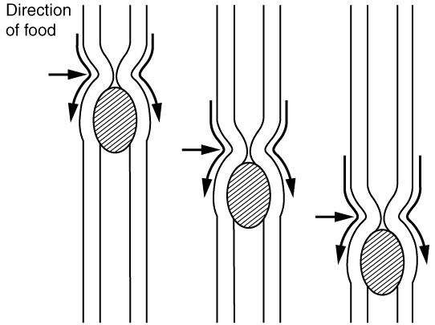
thermal energy | chemical reactions that break down food create this | 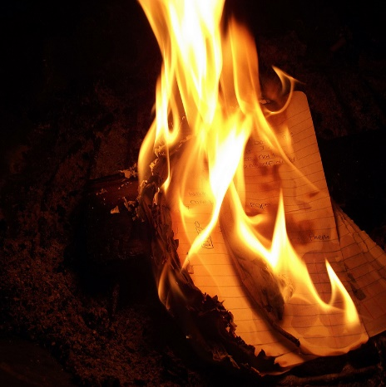

digestive system | all of the parts of the body needed to mechanically and chemically break down food | 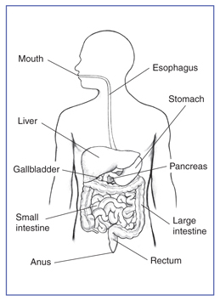
chemical change | change in the identity of a substances that results in creating a new substance | 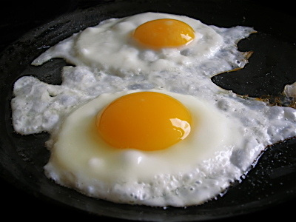
physical change | change in the properties of a substance | 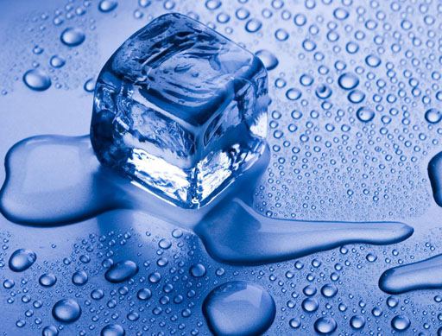

stomach | chemically and mechanically digests food | 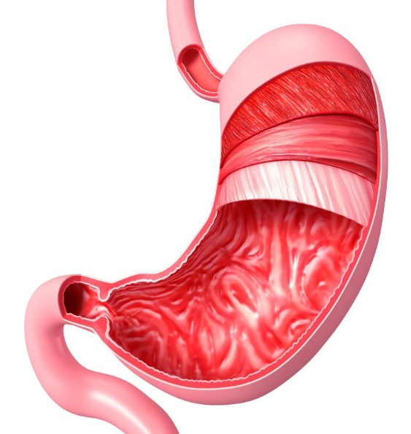
mouth | breaks down food into small pieces and mixes food with saliva to start the digestive process | 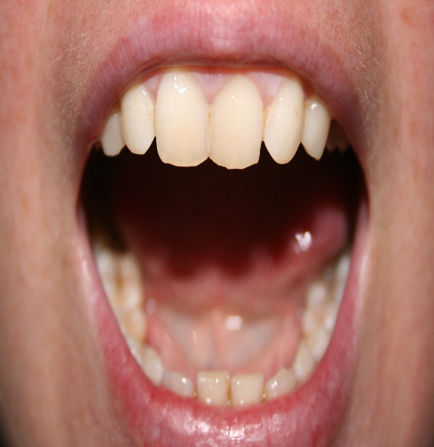
esophagus | pushes food from the throat down to the stomach | 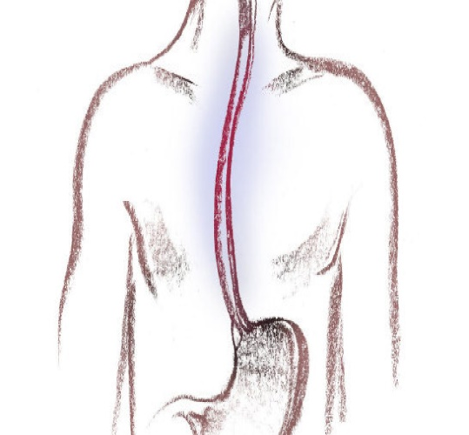

small intestine | absorbs nutrients and helps digest food | 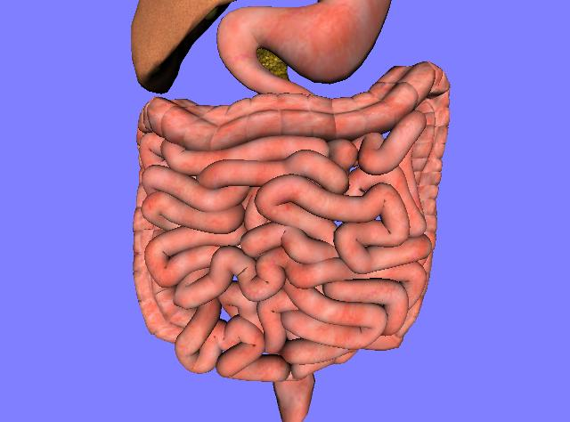
large intestine | absorbs water and passes useless waste from the body | 