**What Time is it?**

#1 Time for Homework!

The big hand is on the twelve. The little hand is on the five.

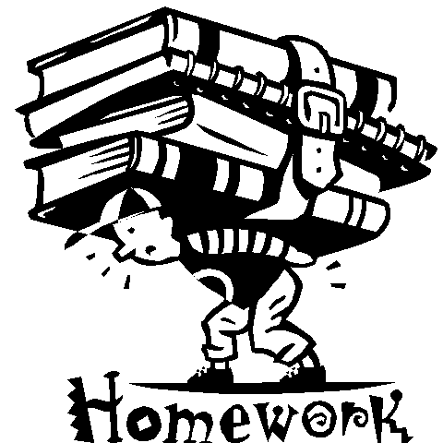

What time is it?

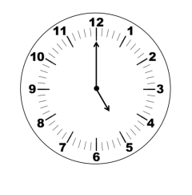

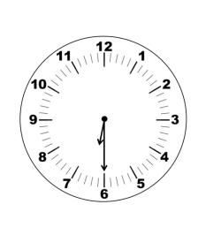

#3 Shower Time!

The big hand is on the nine. The little hand is between the seven and eight.



What time is it?

What time is it?

#2 Time for Dinner!

The big hand is on the six. The little hand is on the six.



What time is it?

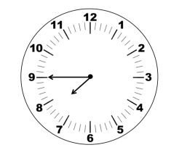

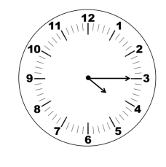

#4 Baseball Practice Time!

The big hand is on the three. The little hand is on the four.



What time is it?

What time is it?

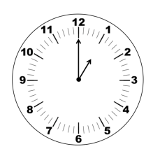

#5 Video Game Time!

The big hand is on the twelve. The little hand is on the one.

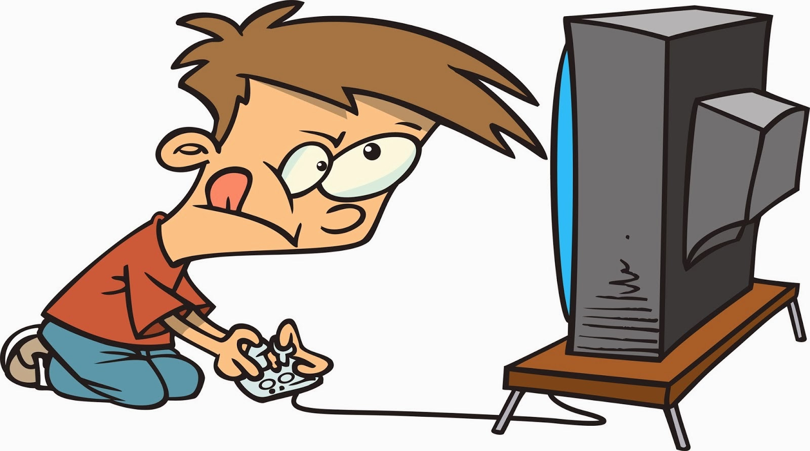

What time is it?

What time is it?

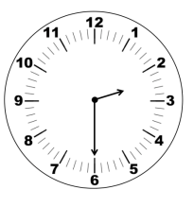

#6 Reading Time!

The big hand is on the six. The little hand is between the two and three.



What time is it?

What time is it?