Valentine One Step Equations

Teacher: Lisa Coates, Rm 603

ETEAMS Members: Amanda Guillory, Lauren Vasquez, and Katie Dion

Materials:

- 1 step Equation Foldables
- SmartBoard and Document Camera
- Markers
- Red and pink construction paper.

TEKS: 6.10(A) Model and solve one-variable, one-step equations and inequalities that represent problems, including geometric concepts

Engage:

- Show them video about how many professions require math: http://www.youtube.com/watch?v=eTGp6VokP5E&sns=em
- Today we are going to show you how there is math in Valentine’s day.
Explore: Model, Write Equations and Solve
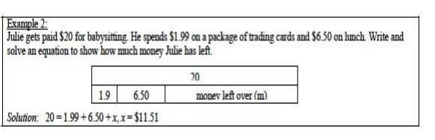
- Open Powerpoint, One Step Valentine Equations
- Go through opening slides on the goal and important reminders when solving equations.
- Pose Problem One (Cookie Crazy) to the students.
- Ask students to talk with a neighbor about how they would solve this problem.
- Circulate around the room.
- Choose three pairs that found different ways of solving the problem to come up to the board and show their solution.
- Show students how they can draw a picture (as above) to model the problem.

Questions:
- How did you solve it?
- How do I know when I am finished?
- What does it mean to isolate the variable?
Additional Questions:
- What makes an equation algebraic?
- What is a variable?
- What is the first step in solving an algebraic equation?
- What is the difference between an expression and an equation?

Explain: (Foldable) http://ispeakmath.org/tag/foldable/

- Use the Heel Dilemna problem as the example for the student foldable
- Define the variable- What am I solving for? (the height of the heel of the ideal shoe)
- What is the variable in this problem?
- Write the equation 67 inches + x = 72 inches
- What is my first step to solve this equation? subtract 67 from both sides
- How do I know which operation to use? opposite operation
- Solve and check x=5, 67 + 5 = 72 inches.
- How do I check to see if my answer is correct?
- Write your answer in a sentence. You should wear a 5 inch heel.
- How do I write my answer into a sentence that makes sense?

Elaborate:

- Students will use the steps provided in their foldable to write an original Valentine word problem.
- If students get stuck on ideas, teachers can suggest: cards, flowers, candy, school dance as possible topics for their word problem.
- Students will be given red or pink paper to write their completed word problem, equation, and solution.
- Ask students to come up with situations that use math in real life
Evaluate:
- Algebra Meltdown: https://www.mangahigh.com/en-us/games/algebrameltdown
