





**by angles**

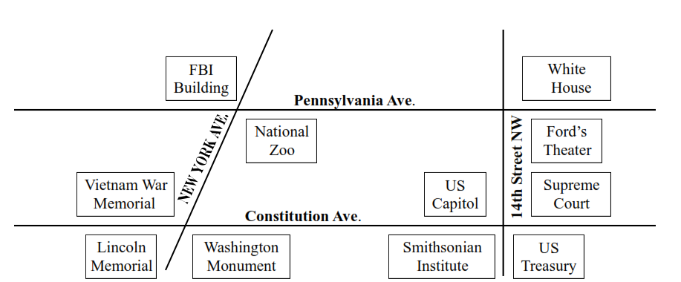

**Where am I?**

1. I am at a vertical angle from the FBI Building. A variety of reptiles, mammals and amphibians from all over the world live here.

Where am I?________________________________

1. I am adjacent to the White House. The 16th president of the United States was assassinated here.

Where amI?__________________________________

1. I form a straight angle with the U.S. Treasury. Important legal matters are decided here.

Where amI?__________________________________

1. I form a vertical angle with the Vietnam Memorial. I am a 555 foot tall marble tower built to honor the first president.

Where amI?__________________________________