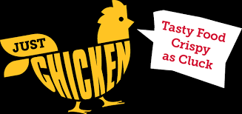
The Clucking Chicken

Use the menu below to record your lunch choices.

MAIN DISHES
CHICKEN BURGER $ 3.25
CHICKEN POPPERS $ 2.99
FRIED CHICKEN $ 3.29
CHICKEN STRIPS $ 2.98

SIDES
MASHED POTATOES & GRAVY $ 2.09
MAC AND CHEESE $ 1.29
FRENCH FRIES $ 1.35
ONION RINGS $ 1.99

DRINKS
SODA $ 1.75
GATORADE $ 1.60
MILKSHAKE $ 1.79

