Taste the Rainbow Lesson Plan

DATE | March 3rd, 2016
PRESENTERS | Dr. Bruun, Mr. Moreno, Ms. Stephens
TEKS | Math 3.8(B) solve one- and two-step problems using categorical data represented with a frequency table, dot plot, pictograph, or bar graph with scaled intervals.
MATERIALS | Fun size skittles packets,pencil, graphing worksheets, colored pencils, laptop, smart board, powerpoint presentation
ENGAGE | Engage students prior knowledge questions. Students will be asked questions to get an understanding of their prior knowledge on the information.  *Can someone identify what type of graphs can be used when recording data?  Pictograph; Tally Chart; Dot plot; Bar Graph; Pie Graph  Have students describe each one.  Teacher will go through the Powerpoint Presentation.  During the presentation ask students questions that are within the powerpoint.  Give students a few seconds to think about it before calling on students  Questions should include:  *Tally Chart Slide: Can someone explain what a tally chart is and how we mark it?  *Pictograph Slide: Why is having a key so important in this type of chart?  *Bar Graph Slide: Can this information from the bar graph be used to form other graphs such as pictograph, and plot graph?  *Plot Graph Slide: What makes this type of graph DIFFERENT from all the other graphs. Can we skip count with this type of graph? Why or Why not?  Transition Question: What is a prediction? What is a reasonable prediction for a small bag of skittles?
EXPLORE | Individual graphing (frequency table and pictograph)  - Making predictions: Predict how many skittles will be in your individual bag?  - Make sure students are aware of the size of the bag and make sure they make reasonable predictions.  - Pass out skittles packets one to each student.  - Have students open their bag of skittles and use the frequency table to mark their own data  - After students have collected data have them create their own pictograph.  - Students need to make sure key is filled out.  - Transition Statement: Based on your data make a reasonable prediction on the red skittle for your group table. For example: Based on my data I predict there will be 25 red in my group.
EXPLAIN | Group Graphing (dot plot)  - Making predictions: Based off of the students individual data they should make a prediction about the total number of red skittles in the group.  - After students have made their predictions, groups will work together and share their data with one another.  - Based on the tables data, students will create a dot plot and. place information on the appropriate graph within the worksheet packet.  - Each student will complete their own individual group chart  - Students are to collaborate with one another to fill out group dot plot on their worksheet  - When students have collected their group’s data teacher will collect data and input it into a bar graph on the following website: http://www.chartgo.com/modify.do; http://www.mathsisfun.com/data/data-graph.php  - Transition Statement: Based on the group data now we can make predictions for the class as a whole.
ELABORATE | Whole class graphing (bar graph)  - Making predictions: Based off of the students group data they should make a prediction about the total number of skittles in the class.  - While the students are making prediction teacher will ask a member from each group table to share their data  - Teacher will input data on website to make a Bar Graph for the whole class. Websites http://goo.gl/ozPZkO  - Have students observe the bar graph and teacher will ask students questions pertaining to the newly created graph.  - Based on the bar graph on the screen which color is most common?  - Which color is least common?  - What is the difference between (pick two colors)?  - Outside of the classroom where else could we use graphs?
EVALUATE | - Students will now complete the packet and answer the questions that are stated.  - Teacher will place questions on smartboard and go through them. Students will have time to answer each question.  - Teacher will assist students if any questions are not clearly understood.  TEKSING toward STAAR questions  #1  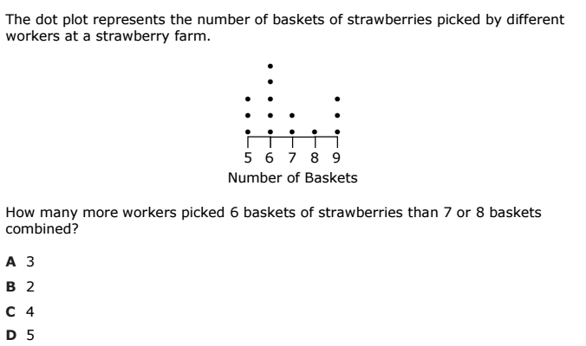

#2
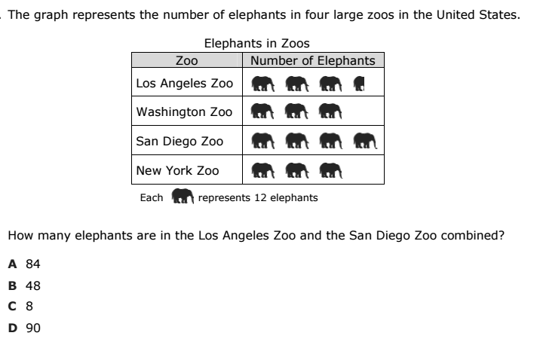
#3
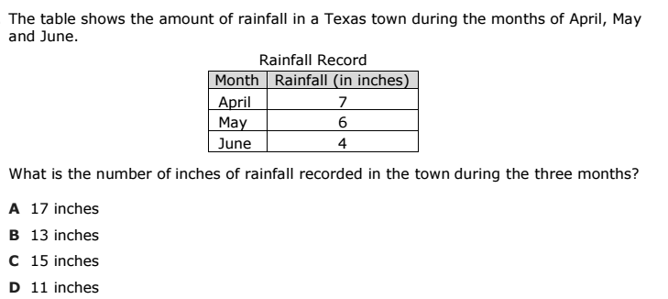
#4
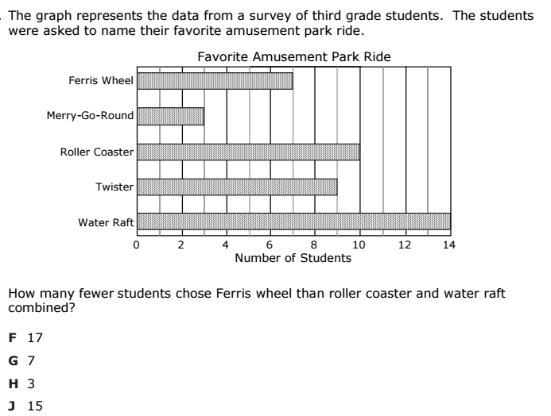
#5
