s

s
s
s

s

s

s

s

s

s

s

Graphing with Skittles

Name: _______________________________ Date: ___________________

I predict there will be _________________ skittles in my bag.

Tally Chart

Color | Tally | Total
Red
Orange
Yellow
Green
Purple

Total Skittles: _______________
Pictograph
s =
Key:

Color | Number of Skittles | Total
Red
Orange
Yellow
Green
Purple

I predict that my group will have ____________ red skittles
s

s

s
s
s

s

s

s

s

s

s

Group Bar Graph
20
19
18
17
16
15
14
13
12
11
10
9
8
7
6
5
4
3
2
1
Red Orange Yellow Green Purple

s

s

s
s
s

s

s

s

s

s

s

Group Dot Plot
20
19
18
17
16
15
14
13
12
11
10
9
8
7
6
5
4
3
2
1
Red Orange Yellow Green Purple

Show whether the listed colors are: <, =, or >

____(R)____(Y)____ ____(P)____(Y)____ ____(G)____(R)____
____(O)____(G_____ ____(R)____(O)____ ____(P)____(O)____
s

s

s
s
s

s

s

s

s

s

s

Write a question using the data from the group graph above and solve:
Question: ____________________________________________________________________________________________________________________________________________________________
Solve (show your work):

s

s

s
s
s

s

s

s

s

s

s

Evaluation

Question #1
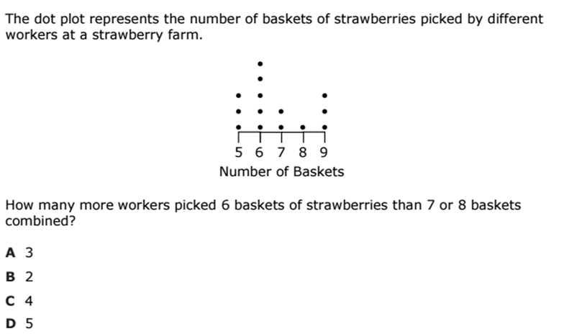

Quest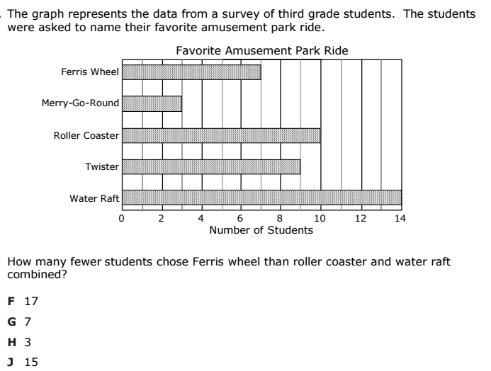ion #2

s

s

s
s
s

s

s

s

s

s

s

Question #3

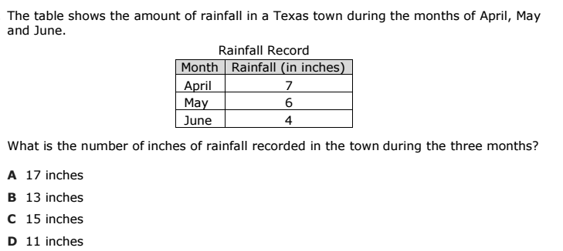

Question #4

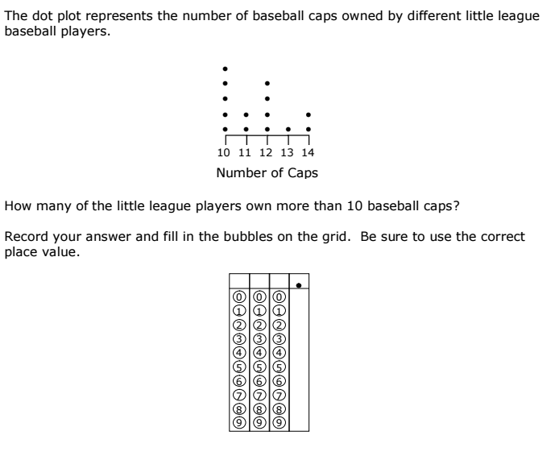

s

s

s
s
s

s

s

s

s

s

s

Question #5

