Teacher: Ms. Moore, Ms. Delagarza, Ms. Devine, Ms. Flanigan
Date: February 25th, 2016
Subject 4th grade math
Materials:
- Student station activity sheet
- 3D Gallon Man: head, 1 gallon w/velcro, 4 quarts w/velcro, 8 pints w/velcro, 16 cups w/velcro, quart, cup, pint, gallons for measuring water.
- Mass: shell, scale, gram stackers, pipe cleaner, tennis ball, golf ball, wooden car, plastic person.
- Length: tape measures
- Time: clocks
- Reference formula charts
- Process charts
- Exit slips

TEKS:
4.8(B) Convert measurements within the same measurement system, customary or metric, from a smaller unit into a larger unit or a larger unit into a smaller unit when given other equivalent measures represented in a table.
4.8(C) Solve problems that deal with measurements of length, intervals of time, liquid volumes, mass, and money using addition, subtraction, multiplication or division as appropriate.
ENGAGEMENT (5 minutes)
- Today we are going to be focusing on measurement. We will be exploring ways to measure length, time, mass, and volume.
Questions:
- What is volume? (how much stuff can fit in the inside of a 3D object)
- What is mass? (how much matter is in an object. We measure it by using a scale)
- As you watch the video, pay attention to different units that we use to measure volume or capacity.
- Show video, When a Cup Grows Up
https://www.youtube.com/watch?v=E4UC_StFhAk
3. How do we measure volume or capacity? (ounces, cups, pints, quarts, gallons)

EXPLORATION (40 minutes)

The students will explore 4 different measurement stations: time, length, mass, volume. They will have a station activity sheet to record the data they find at each station.

- Length: students will measure their heights. They will then calculate the total heights of all group members. They will also calculate the difference between the tallest and shortest student.
- Mass: students will be given 8 objects with varying masses. They will be asked to look for objects that weigh a specific mass. They will first predict which object matches which mass. They will then weigh the objects one at a time using gram stackers and a scale. They will also explore two items that are measured in kilograms and convert them to grams.
- Capacity/Volume: Students will use water to discover how many cups make a pint, how many pints make a quart and how many quarts make a gallon. They will then put together the velcro gallon man. Finally, they will record on their activity sheet the relationship using this image:

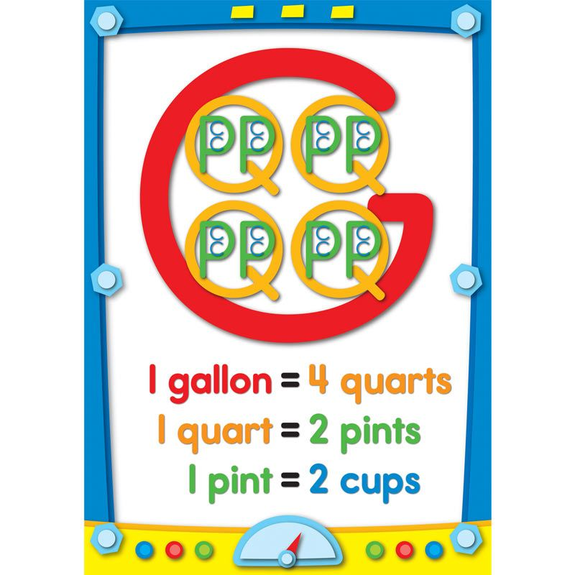
4. Time: Students will calculate what time they need to set their alarm given the time school starts and the tasks they need to accomplish before school (teeth brushing, shower, video game playing, walking to school, getting dressed). They will have clocks to help them with this task. They will then create their own morning schedule with times for each activity that they do given the wake up time and time school starts.
EXPLAIN

The students will gather as a class and share information about each station. The teacher will ask questions:

What units do we use to measure mass?

What units do we use to measure time?

What units do we use to measure length?

What measurement would we use to measure the mass of a feather? the mass of a bowling ball?

What measurement would we use to measure the amount of water in a bathtub?
ELABORATION (7-10 minutes)

Students will complete tables showing the relationships between the various units of measurement. The teacher will go through example problem with the whole class.

EVALUATION (7-10 minutes)

3-2-1 Exit Slip
- Students will be given their exit slips. They will have a few minutes to get with a buddy and share ideas.
- Students will then write their ideas on the exit slips as their ticket out the door.

3 Things I Learned Today …

2 Questions I Still Have …

1 Opinion about the Lesson...

