

Measurement Relationships

**Example**

**Directions: Use your Reference Chart to complete each table. Make sure to fill in the titles for each column.**

**1)**

|  |  |
| --- | --- |
| **Number of kilograms** | **Number of**  **grams** |
| 1 |  |
| 2 | 2,000 |
| 3 |  |
| 4 |  |
| 6 |  |
| 8 |  |
| 10 |  |

Number of kilograms x _____ = the number of grams.

Number of ________ 1,000 = the number of ___________.

2. A parrot weighs 600 grams. Mama parrot and Papa parrot are sitting on a tree branch. How many **kilograms** do they weigh together?

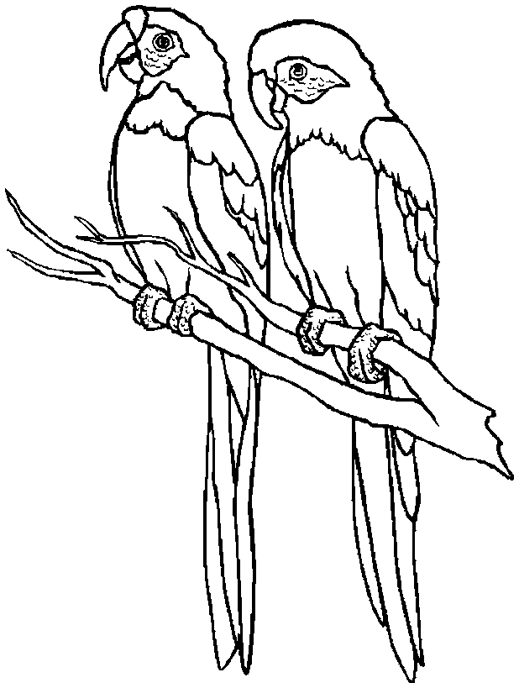

**Word Problems**:

1. A koala weighs 9 kilograms. A polar bear weights 475 kilograms. How many more **grams** does a polar bear weigh than a koala bear?



**2)**

|  |  |
| --- | --- |
| **Number of**  **grams (g)** | **Number of**  **_________** |
| 1,000 |  |
| 2,000 |  |
| 3,000 |  |
| 5,000 |  |
| 10,000 |  |
| 20,000 |  |
| 50,000 |  |