Mass Masters

Teachers: Ms. Moore, Ms. Pardom, Ms. Dion, Ms. Rodriguez, Ms. Perales
Date: March 3, 2016 (STEM Thursday)
Subject / grade level: 4th Grade Math, Geometry and Measurement
Materials:
- gram stackers (2 sets)
- balance scales (2)
- objects to calculate mass of in grams (Mass Predictions)
- objects to calculate mass of in kg. (What’s my mass?)
- 4th grade reference charts (class set)
- 2 scales
- objects to put in backpack
- Station Activity Sheet
- Measuring Relationships Student hand-out
- Base ten blocks
- Butcher paper divided into eight rectangles

TEKS:
4.8.A Identifying relative sizes of measurement units within the customary and metric systems;

4.8.B Convert measurements within the same measurements system, customary or metric, from a smaller unit to a larger unit or a larger unit into a smaller unit when given other equivalent measures represented in a table; and

4.8.C Solve problems that deal with measurements of length, intervals of time, liquid volumes, mass, and money using addition, subtraction, multiplication, or division as appropriate.
ENGAGEMENT

- Tell the students that today we will be exploring mass and weight. We will now show a video to get you thinking about what units we use to measure length, volume and mass. https://www.youtube.com/watch?v=hY6K5eNkxp8
- Questions:
  - What units do we use to measure mass or weight?
  - Which is bigger, a gram or kilogram?
Transition: Today we are going to be exploring the relationship between grams and kilograms and how we can solve problems about mass.
EXPLORATION
Station One: What’s the mass?
Measuring Mass:
You will be measuring the mass of some objects using gram stackers. First you will predict which objects match the mass shown below. Then you are to weigh the objects to test your predictions. Objects:

Mass | Prediction | Actual Object
20 grams
7 grams
190 grams
66 grams

What’s the weight?

- Students will measure the mass of each of 5 items using a doctor’s scale.
- They will determine the total mass of the 5 items .
- They will determine the difference between the heaviest and lightest objects.

Station Three: Sharing Chocolate

- Students will be given the following problem: Ms. Perales has 2 kilograms of chocolate to share with 8 students who have perfect attendance. How much chocolate in grams does each student get.
- Students will use their reference chart to find the conversion between grams and kilograms.
- Students will use Base 10 Blocks to model this problem and solve.
- Students will use 20 100 blocks to equal 2,000 grams or 2 kilograms. Each of 8 people will get two 100 blocks.
- The four remaining 100 blocks will be renamed as 40 ten rods.
- The forty rods will be divided so each friend gets 5 10’s.
- 2 100’s plus 5 10’s equal 250 grams per student.

Station Four: Backpack Challenge
1. The teacher will show the following video: https://www.youtube.com/watch?v=JKBs-hpINiw
2. The teacher will explain that the average 4th grader weighs 36 kilogram. The amount of weight that the experts recommend the student carry in their backpack is 6 kilograms. Students will weigh items that they could possibly put in their backpack and choose which things they would bring, making sure not to exceed 6 kilograms.
EXPLANATION

- What units do we use to measure mass?
- Can you describe the relationship between grams and kilograms?
- What measurement would we use to measure the mass of paper? the mass of brick?
ELABORATION

- Students will use the information they learned during the Explore and Explains pieces to complete tables showing the relationship between grams and kilograms.
- They will then solve word problems. They will be allowed to work with their elbow buddy to solve these problems although all the students are expected to show work on their own papers.
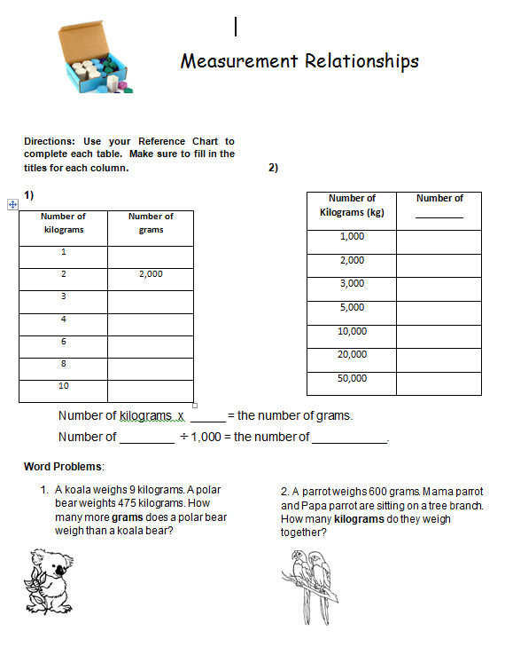

EVALUATION
STAAR Formatted Questions:

