Teachers: Mr. Hastey, Ms. Moore, Ms. Pardom, Ms. Pedrazine, Ms. Silvas, Ms. Solis
Date: 2/11/2016
Subject / grade level: 8th grade math
Materials:
- Clucking Chicken Prices Hand-out
- Age of Presidents box plot hand-out
- Graphic organizer
- Ruler
- Masking tape
- index cards
TEKS:
(12 C) summarize numeric data with numerical summaries, including the mean and median (measures of center) and the range and interquartile range (IQR) (measures of spread), and use these summaries to describe the center, spread, and shape of the data distribution; and
Vocabulary: minimum, maximum, median, interquartile range, lower quartile, upper quartile, Q1, Q2, Q3, Q4, mean, mode, range

ENGAGEMENT
- Today we are going to watch a brief video called Mean, Median, Mode, Range. https://www.youtube.com/watch?v=IHginNwss5c
2. Questions:
- How do we find the median?
- How do we find the range?
- Why might you be interested in knowing how to find the mean?
EXPLORATION

- Clucking Chicken): http://illuminations.nctm.org/Lesson.aspx?id=1688
- Students will be divided into five groups. Each group will be given a large index card and a ‘Clucking Chicken’ order sheet.
- As a group, the students will choose one main dish, one side and one drink. They will calculate the total for their order and write the price (no tax ) on the index card using a marker.
- One student from each group will come to the front of the room.
- The students will line up from lowest to highest price.
- Another student from each group will be called up to stand beside their teammate. They will receive cards with the following labels: minimum, maximum, median, lower quartile (Q1), upper quartile (Q2).
- We will then make a box using rulers/tape
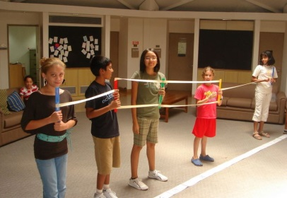
- We will ask students:
  - What is the range of this data?
  - What do we call the lowest data point? highest? one in the middle?
  - Finally we will introduce the term Interquartile range (difference between Q1 and Q3).
EXPLANATION
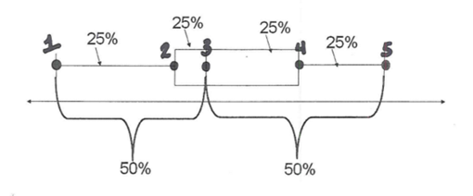
- Students will be given a hand-out with this image.
- Teacher will show students Box and Whisker Powerpoint.
- The students will be asked to identify each point on the image above and to define both the range and interquartile range.
- The students will disucss why the distance is always the same between each of the five data points.

ELABORATION

- The students will use the information that they have explored and explained to work on an activity as a group.
- How old were they? http://www.tarleton.edu/ORG/team/documents/6to8/lessons/8/probability8_2.pdf
- This activity looks at the ages of 20th century presidents and vice-presidents when they were inaugurated. Students will work on this activity in their groups.
- They will each complete their own hand-out but will be able to work cooperatively throughout this activity.
Questions:
- The youngest president was John F. Kennedy. How old was he at his inauguration?
- The oldest president at inauguration was Ronald Reagan. How old was he at his inauguration?
- What was the median age at inauguration?
- What percentage of the presidents were over 60 (the upper quartile)?
- What percentage of the presidents were under 51 (the lower quartile)?
- What do you notice when you compare the ages of presidents with vice-presidents?

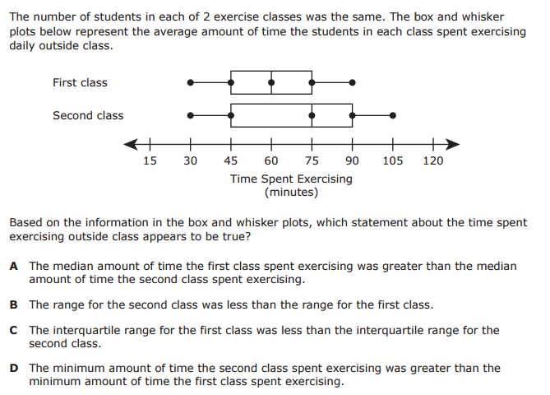
EVALUATION:

- The powerpoint includes two practice evaluation questions. The students will answer these on the back of their notes page.
- The last question is from a released STAAR test. Students will answer this question on the back of their notes page as well.

