_________________ began ___________________________ at 2:05.
It took 36 minutes to ______________________________.
What time will ___________________________________________?
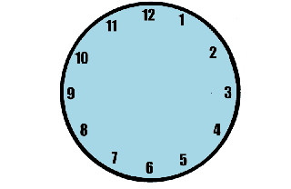

_________________ began ___________________________ at 5:25.
It took 19 minutes to ______________________________.
What time will ___________________________________________?

________________ began ___________________________ at 12:10.
It took 47 minutes to ______________________________.
What time will ___________________________________________?

_________________ began ___________________________ at 3:15.
It took 12 minutes to ______________________________.
What time will ___________________________________________?

