Dropping Objects

When an object is dropped, the speed with which it falls continues to increase (due to gravity pulling it faster downward!). The formula
h = -16t² + s
models the height of the object with respect to time. h = height, t = time in seconds and s = starting height

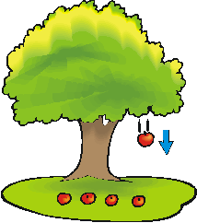
Create a model for the height of an apple that drops off a tree when it started on a branch 20 feet above the ground.

Label:
- X axis (time)
- Y axis (height)
- Vertex (maximum)
Draw:
- Sketch of the graph

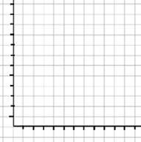

Example 1
Phil drops a ball from the top of a cliff. It is 215 feet to the ground. How long does it take the ball to hit the ground below the cliff?

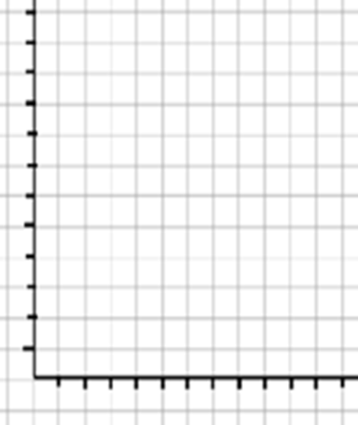
Example 2
How long does it take a free-fall ride at an amusement park to drop 121 feet (and they stop 1 foot short of the ground)?

