Name_____________________

Matchbox Friction

**Materials:**

matchbox car

binder

bath mat or carpet

tape Measure

blanket

**Hypothesis:** I think the Matchbox car will travel furthest on the ___________ because ___________________________________________________________ __________________________________________________________________.

**Procedure:**

**Step 1:** Go to your first station. A yardstick, binder (ramp), and Matchbox car will be there. Do not move the binder.

**Step 2:** Place the Matchbox car at the top of the ramp with its back at the edge. Let the car go! Allow it to roll until it stops.



**Step 3:** Using the tape measure, measure how many centimeters the car rolled between the bottom of the ramp and the back of the car, where it stopped. Record the distance on the table next to the type of surface that the car traveled on. Repeat two more times and record those results.

**Step 4:** Switch stations when the teacher tells you to. Repeat steps 2-3, making sure to record your data.

|  |  |  |  |
| --- | --- | --- | --- |
|  | Trial 1 | Trial 2 | Trial 3 |
| Tile | cm | cm | cm |
| blanket | cm | cm | cm |
| mat | cm | cm | cm |

**Results**

1.The car rolled the furthest distance on _________ and the shortest distance on __________.

2. My hypothesis was ________ because

__________________________________________________________________.

**Conclusion**

3. What surfaces provide the most friction? __________________________________________________________________

4. What surfaces provide the least friction? __________________________________________________________________

5. When would an increase in friction be good? _________________________________________________________________

6. When would a decrease in friction be good? ___________________________________________________________________

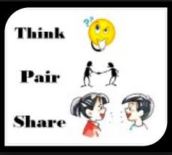

What are some outdoor experiments we could do to learn about friction? _________________________________________________________________________________________________________________________________________________________________________________________________________________________________