Feed the Birds Data Collection Chart
Name___________________
My Beak: | Paper Clips | Rubber Bands | Marshmallows | Marbles

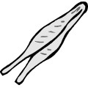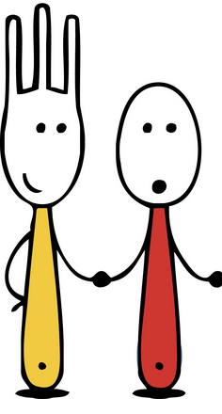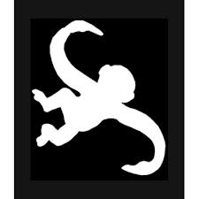
 | Paper Clips | Rubber Bands | Toothpicks | Marbles
Forkbills
Spoonbills
Hookbills
Tweezerbills

Fork
CP
CP
Spoon
Fork
CP
Hook

CP
Hook

Hook
Hook

Spoon
Fork
Spoon
Spoon
Fork
bills

