How Do Landforms Form?

Volcanoes:
Station 1 and 2: How does an erupting volcano affect Earth’s surface?

1st Lava Flow | 2nd Lava Flow
3rd Lava Flow | 4th Lava Flow

1. How do volcanoes change the Earth’s surface?

2. Do volcanoes change Earth’s surface quickly or slowly? Explain.
________________________________________________________
________________________________________________________
________________________________________________________

Stations 3 and 4: How do landslides change the land?

Before the Rain After the Drizzle Heavy Rain

1. What forces cause landslides?

2. Do landslides tear down, build up, or both? Explain

Stations Five and Six: Earthquakes
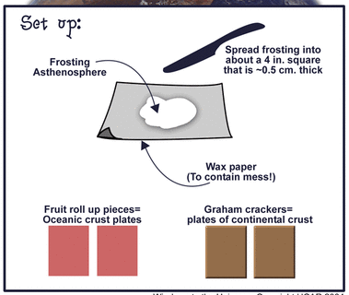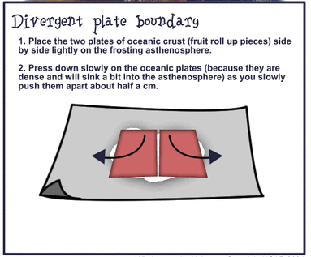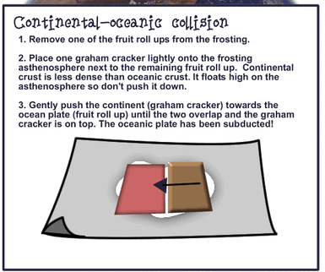
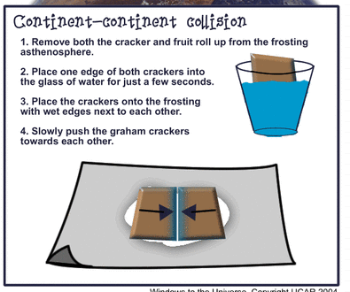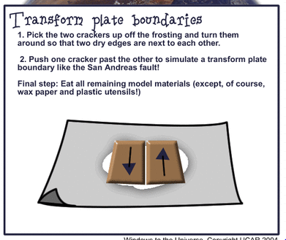

- What did the graham crackers represent?______________
- What did the fruit roll up represent?______________
- What did the icing represent?______________
- What happens when two plates come together (converge)?____________
___________________________________________________________

- What happens when two plates separate (diverge)?__________________
___________________________________________________________

- What happens when two plates slide against each other?_____________
___________________________________________________________

