

**Toys “R” Us**

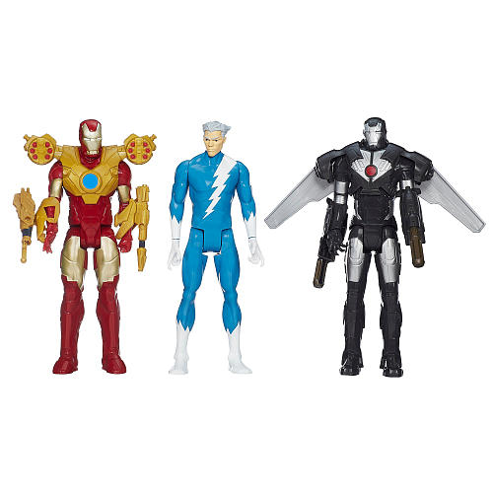Marvel Avengers Titan, Quicksilver, Marvel's War Machine, and Iron Man **$300**

Minions talking Bob **$250**

http://weeklyad.toysrus.com/Content/images/cleardot.png

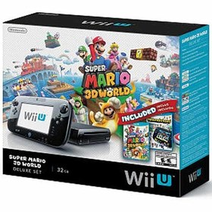Wii U gaming system **$545**

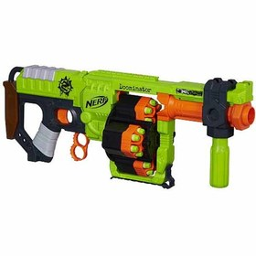NERF Zombie Strike **$165**

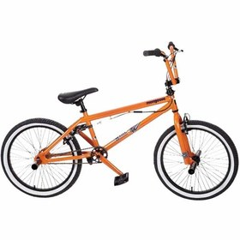NEW! Mongoose Jam Series bike **$485**

http://weeklyad.toysrus.com/Content/images/cleardot.png 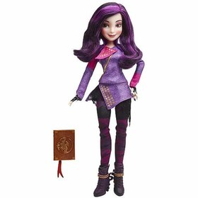

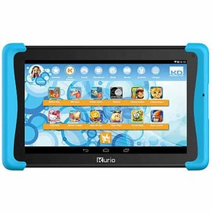Kurio Xtreme 2 Kids Tablet **$325**

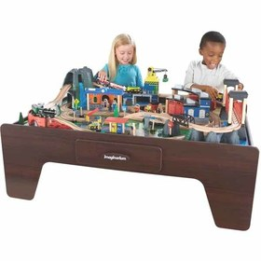Imaginarium Mountain Rock Train Table and 105-pc. Train Set with Lights & Sounds **$435**

Crayola Creations Thread Wrapper Fashion Edition **$275**

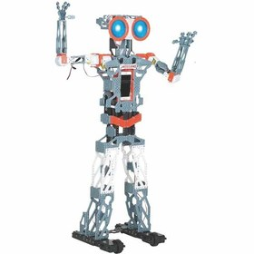Spin Master Meccanoid G15 KS Personal Robot Kit **$745**

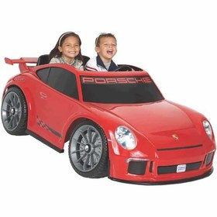Power Wheels 12-volt Porsche CT3 **$885**

ALL Disney Descendants dolls, play sets & doll accessories **$195**