Exploring Reptiles
- What angles are in the interior of this rep-2 triangle? 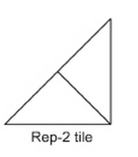
- What angles are in the interior of this rep-3 triangle?

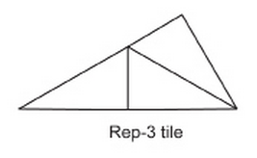

Directions: You may use a protractor, a ruler, or any other strategy you can think of to answer the questions below.
SHAPE A
- What is the perimeter of shape 1A?______cm
- What is the perimeter of shape 2A? ______cm
- Describe the relationship between the perimeters of shape 1A and 2A?
____________________________________________________________
- What is the area of shape 1A?______cm
- What is the area of shape 2A? ______cm
- Describe the relationship between the area of shape 1A and 2A?
____________________________________________________________
SHAPE B
- What is the perimeter of shape 1B?______cm
- What is the perimeter of shape 2B? ______cm
- Describe the relationship between the perimeters of shape 1B and 2B.
____________________________________________________________
- What is the area of shape 1B?______cm
- What is the area of shape 2B? ______cm
- Describe the relationship between the area of shape 1B and 2B? ___________________________________________________________
- What are the measurements of the angles in shapes 1B and 2B?___________

