- One elephant schnoz’ll X 10 = ________ squid tentacles.

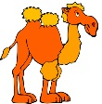
- Two camel humps X 10 = __________ sage grouse feather spikes

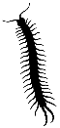
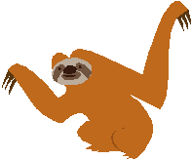
- Three – toed sloth X 10 = ___________ centipede feet.

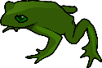
- Four wild boars X 10 = ___________ frog warts.

- Five starfish arms X 10 = __________ fish in a school.

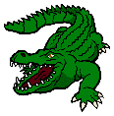
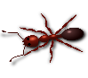
- Six ant legs X 10 = __________ croc teeth.

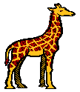
- Seven raccoon halos X 10 = _________ giraffe spots.

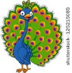
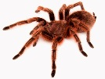
- Eight tarantula legs X 10 = _________ peacock eyes.

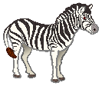
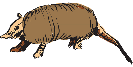
- Nine armadillo bands X 10 = _________ zebra stripes.

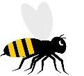
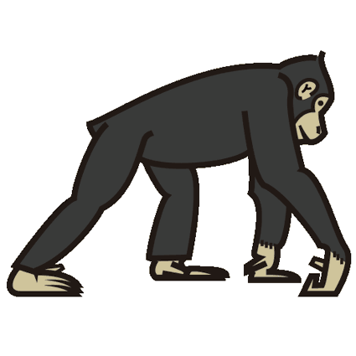
- Ten chimpanzee toes X 10 = __________ bubble bees.

