 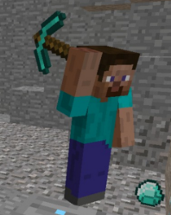

**Problem One: What is the area of this chest?**

**Minecraft Multiplication**

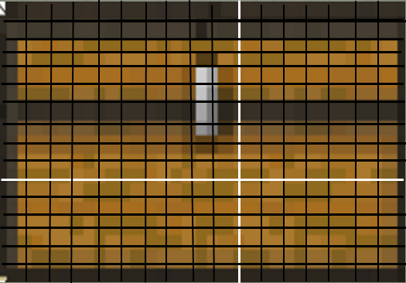

**Problem Two: There are 15 minecraft pigs. Each minecraft pig eats 27 carrots a week. How many carrots do all the pigs eat in one week?**





**Problem Three: Steve is mining gems. He mines 13 gems per hour. How many gems does he mine in one day if he mines all day without stopping?**



