Name_________________ Date__________
Making Ice Cream in a Bag LAB PACKET
Materials:
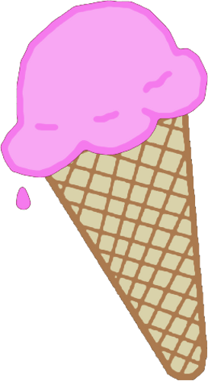
- 1 Cup of milk
- ¼ tsp. vanilla
- 4 tbsp. sugar
- 3 to 4 cups of crushed ice
- ¼ cup of rock salt
- Big measuring cup
- Small measuring cup
- Measuring spoons
- 1 plastic cup
- 1 plastic spoon
- 1 Gallon sized Ziploc bag
- 1 Sandwich sized Ziploc bag
- Thermometer
- Goggles
- Gloves
- apron

Which of the materials are solids? Which are liquids?

Materials | Solid | Liquid
Milk
Vanilla
Crushed Iced
Rock Salt
Sugar

Hypothesis: I think that the mixture of milk, sugar, and vanilla will change states from a _____________ to a ____________ BECAUSE ________________________________________________________________________________________________________________________________________________________________________________.

Procedure for making the ice cream:

- In the plastic cup, mix together milk, sugar and vanilla. Carefully, pour the mixture from the cup into the sandwich size Ziploc® bag. Close the bag while carefully removing air. Make sure the bag has a tight seal.
- In the large Ziploc® bag, add 3-4 cups of ice. Take the temperature of the ice with a thermometer. Record the temperature and other observations on your data sheet.
- Add the rock salt to the ice.
- Place the small bag inside the large bag. Carefully close the bag while removing any excess air. Make sure the bag has a tight seal.
- Get ready to shake it up! After 5-10 minutes, the ice cream should be hard enough to eat.
- Take a temperature reading of the ice and salt mixture. Record your observations on your data sheet.
- Find the difference in temperature between the ice and the ice-salt mixture. Record your observations on your data sheet.
- Finally, the moment you have been waiting for... place the bag of ice cream on a paper plate, open up the bag, grab your spoon and enjoy!

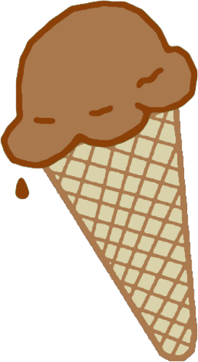

Observation Record:
 | Temperature | Observations | State of Matter
Before
After

Explaining our Results:

Explain what happened to the liquid mixture of milk, vanilla and sugar.
_______________________________________________________________

_______________________________________________________________

_______________________________________________________________

Did the evidence support your hypothesis? Explain your answer in a complete sentence. _______________________________________________________________

_______________________________________________________________

______________________________________________________________.

