Function Review Lesson Plan
Teacher:
Ms. Bradshaw, Ms. Ybarra, Ms. Lopez, Mr. Gabel
Subject / Grade Level:
Algebra 1 / 8th Grade
Date:
September 10, 2015
Materials:
Warm –up questions on SMART Board
Functions Jeopardy
15-30 White boards and dry erase markers
Ticket out the Door (60)
Basketball
Basketball Scenarios Student worksheet

TEKS:
1.8 TEKS
A.3(c) Graph linear functions on the coordinate plane and identify key features including x-intercept, y-intercept, zeros, and slope, in the mathematical and real world problems.
A.7(a) Graph quadratic functions on the coordinate plane and use the graph to identify key attributes, if possible including x-intercept, y-intercept, zeros, maximum value, minimum values, vertex, and the equation of the axis of symmetry.
Lesson Objectives:
SWBA to analyze mathematical relationships to connect and communicate mathematical ideas.
SWBA to display, explain, and justify mathematical ideas and arguments using precise mathematical language in written or oral communication.
Differentiation Strategies to Meet Diverse Learner Needs:
Using the white boards will allow a kinesthetic approach to understanding the key concepts.
Engagement (7 minutes)
- The teacher will tell the students that they are going to watch a video to help them remember what makes a function a function.
- Show video: https://www.youtube.com/watch?v=sE4eq0cjLFk . The video goes over the following information about functions:
- Each x has only one y
- There is one and only one output (range) for every input (domain)
- The teacher can ask the students what else they know about functions (how to identify on a graph, on a diagram, verbal description).
- Examples:
  - Function would not cross two points when you make a vertical line anyplace on its graph.
  - On a diagram: function on left, not a function on right.
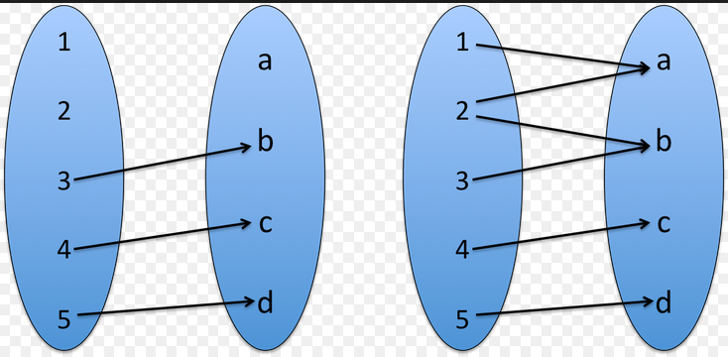
  - A scenario that is a function is students (x) and the class period they have math (y). A scenario that is not a function is a teacher (x) and the students that are in his math class (y).
- What do we can a graph, table or diagram that shows sets of ordered pairs that do not make a function? RELATION
Exploration (20 minutes)
- The students will play Functions Jeopardy.
The Rules:
- The students will be at 6 different tables
- Two students at the table will be able to answer the questions at a time on the white boards, then the following turn the boards are expected to be passed to the other table mates.
- Only the table who is up to answer will call out the answer
- The other groups should still work on the problem:
  - If the answering team answers incorrectly, then it goes to double jeopardy where all remaining groups will show their answers. The teams that are correct will get points.
- If there is too much off task talking, teams may lose points
  - Each warning after the initial taking off of points will result in double the points being taken away.
- A timer will be set for each question;
- Students will be instructed to choose from the following categories:
  - Is it a Function?
  - Linear or non-linear?
  - Evaluating
Explanation
When students are unable to answer a certain question; the teacher can use that time as a teachable moment to explain the process of the question to the class. Important concepts:
- Linear functions form one straight line
- Linear functions have a constant rate of change
Elaboration (15)
- Show PBS Math and Basketball: http://www.pbslearningmedia.org/resource/mmpt-math-f-basketball2/basketball-and-functional-relationships/. After each segment, use a real basketball to demonstrate the throw.
- You can also point out to the students the y intercept (where is the graph when x=0). Do these graphs start at the origin? Why or why not? What would it mean if they did start at the origin (the ball would be on the ground). What does the x and y axis represent on these graphs (x= height of the ball, y= distance from the original thrower).
- The teacher will pass out the basketball scenarios worksheet. Students are to write individually what scenario could have created the graph shown. Students may discuss this with their group members.
- Are these graphs linear?

Evaluation (5)
Questions:
- How do you know if a graph is linear or non-linear?
- How do you identify a function?

Ticket out the door
Students will answer a question pertaining to the graph of a function.
The question can be found on page 66 of the student Algebra 1 textbook, number 75.
There will be quarter pages prepared for this with the question already on it.

