MUG WUMPS: Exploring Similarity
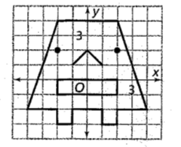.
Directions: Using the picture above, complete the (2x, 2y) column to determine the ordered pairs to create a dilated Mug Wump. Plot the points. Personalize your wump.
Rule | (x,y) | (2x, 2y)
Body  Outline | (-4, -2)
 | (-2, -2)
 | (-2, -3)
 | (-1, -3)
 | (-1, -2)
 | (1, -2)
 | (1, -3)
 | (2, -3)
 | (2, -2)
 | (4, -2)
 | (2, 4)
 | (-2,4)
Nose | (-1,1)
 | (0,2)
 | (1,1)
Mouth | (-2, -1)
 | (-2,0)
 | (2,0)
 | (2, -1)
Eyes | (-2, 2)
 | (2, 2)

