**Name_______________**

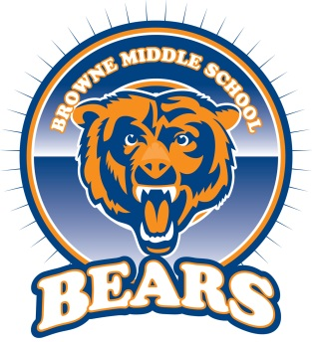

**Beary Good Snack Mix**

**Recipe for Bears Snack Mix**:



PER TWO STUDENTS

1/4 cup of cheerios

1/3 cup of goldfish

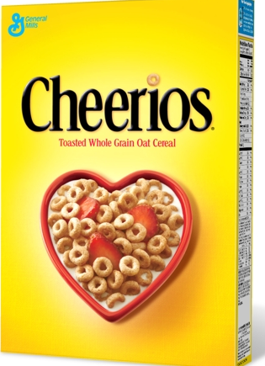

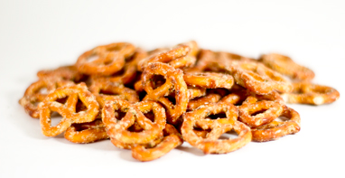

1/4 cup of marshmallows

1/2 cup of pretzels

**STEP ONE:** Calculate how to make enough snack mix for your entire group.

______ cup of cheerios

______cups of goldfish

______cup of marshmallows

______cups of pretzels

**STEP TWO:** Create the snack mix for your entire group using the recipe you have calculated.

**STEP THREE**: Calculate how many total cups of snack mix you have created for your entire group.

______ cup of cheerios

______cups of goldfish

______cup of marshmallows

______cups of pretzels TOTAL AMOUNT OF SNACK MIX:________CUPS

**STEP FOUR**: Calculate how much snack mix each person in your group will get if it is distributed evenly. Remember to always express your answer in simplest terms.

**EACH PERSON GETS _______CUPS OF SNACK MIX**

**STEP FIVE**: Distribute the snack mix between your group members evenly.

**STEP SIX**: Using the steps above, how much of each ingredient will be needed to serve ten people.

______ cup of cheerios

______cups of goldfish

______cup of marshmallows

______cups of pretzel

TOTAL AMOUNT OF SNACK MIX:________CUPS

Explain your work.

_____________________________________________________________________________________________________________________________________________________________________________________________________________________________________________________________________________________________________________________________________________________________________________________________________________________

**STEP SEVEN CHALLENGE**: What if you needed to make enough Bears Snack Mix for the entire school of 500 students? How would you calculate how much of each ingredient will you need to supply the entire school?

______ cup of cheerios

______cups of goldfish

______cup of marshmallows

______cups of pretzels

TOTAL AMOUNT OF SNACK MIX:________CUPS

**TIME TO EAT!**