 |  | Date | Relevant Information
May
 | Attend Orientation | 5/06 | ECMS Building
June
 | Participate in a total of 25 hours of authentic science research on campus | Hours need to be completed by 7/24 | It is your responsibility to communicate with professors and ETEAMS faculty to get your hours in.
 | Attend ME by the SEa math and science conference (counts as 6 hours). | 6/19 | 8:30-4:00 in the Center for Instruction. Register at:  http://domathtogether.com/me-by-the-sea-2015-registration/  *the grant is paying for your registration fee  This is an optional activity and will NOT count towards your summer hours.  PLEASE NOTE: There will be training at ME by the Sea on creating an electronic log/webpage.
 | CAMT | 6/24-6/26 | Houston Convention Center.
 | Complete Timesheet | Throughout research experience | Bring to Summative Meeting
 | Complete Field notes questions | Throughout research experience | Bring to Summative Meeting
 | Take photos of research | Throughout research experience | Bring to Summative Meeting
July
 | Complete one Electronic Log | Before 7/31 | Prepared to share webpage at Summative Meeting
 | Create one 5E Lesson Plan | Before 7/31 | Bring to Summative Meeting
 | Summative Meeting | Friday, July 31st | 10:00-3:00 in the ECMS building.
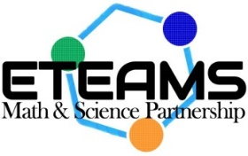
ETEAMS Teacher Checklist
Summer Contacts:
Dr. Lee Smee at Lee.Smee@tamucc.edu
Avery Scherer at Avery.Scherer@tamucc.edu
Kelly Correia at kcorreia@islander.tamucc.edu

