Name_______________
Shamrock Snack Mix
Recipe for Shamrock Snack Mix: feeds four students
½ cup of marshmallows
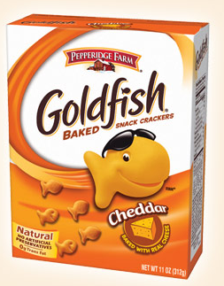
1 cup of cheerios
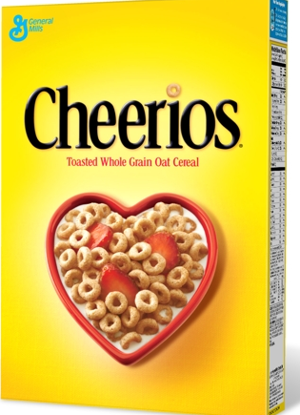
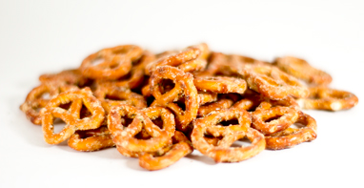
1 cup of goldfish
2 cups of pretzels

STEP ONE: MEASURE all your ingredients into a bowl.
STEP TWO: LIST the ingredients in order from the one that you have the least of to the one that you have the greatest amount of.

STEP THREE: How many cups of snack mix do you make if you follow this original recipe?

STEP FOUR: EXPLORING RELATIONSHIPS
- What is the relationship between the amount of goldfish and marshmallows?

- What is the relationship between the amount of pretzels and marshmallows?

- What is the relationship between the amount of marshmallows and the total amount of Shamrock Snack Mix?

STEP FIVE: Rewrite the Recipe to make enough Shamrock Snack Mix for the class, twenty students.
Use RATIOS to help you.

1 cup of Cheerios cups of Cheerios
1. The list shows the amount of each ingredient Charlotte used to make 3 servings of shamrock snack mix.
* 2 cups of pretzels
* ½ cup of mini marshmallows
* 1 cup of goldfish
* 1 cup of cheerios
Based on this information, which statement is not true?
A. To make 6 servings, Charlotte should use 1 cup of marshmallows.
B. To make 24 servings, Charlotte should use 8 cups of pretzels.
C. To make 1 serving, Charlotte should use 1 cup of pretzels.
D. To make 9 servings, Charlotte should use 3 cups of goldfish.
2. If each Shamrock snack mix recipe feeds 4 people, using the measurements above, how many ounces would each person be served?
A. 32 ounces
B. 4 ½ ounces
C. 40 ounces
D. 16 ounces
3. The pictograph below shows the amount of ingredients being used in the Shamrock snack mix:
Ingredients in Shamrock Snack Mix
Pretzels
Marshmallows
Gold Fish
Cheerios
= 1 cup of ingredient
Which statement is best supported by the information presented in the pictograph?
A. There are a total of 5 cups of ingredients
B. The ratio of the amount of cheerios to the amount of pretzels is 2 to 1
C. The difference between the amount of cheerios in the mix and marshmallows is 1 cup.
D. The ratio of the amount of Gold Fish to Pretzels is 1 to 2.
4. While making lemonade Scott realizes his lemonade is extremely sweet. He looks back at the ingredients and realizes the ratio of water to sugar was 3 to 2. What could Scott have accidentally done to make the lemonade so sweet?
____________________________________________________________________________________________________________________________________________________________________________________________________________________________________________________________________________________________________________________________________________________________________

1 batch 5 batches

1 cup of goldfish cups of goldfish
1 batch 5 batches

1/2 cup of marshmallows cups of marshmallows
1 batch 5 batches

2 cups of pretzels cups of pretzels
1 batch 5 batches

HOW MANY TOTAL CUPS OF SNACK MIX FOR A WHOLE CLASS?______

STEP SIX: TIME TO EVALUATE
1. The list shows the amount of each ingredient Charlotte used to make Shamrock Snack Mix for four students.
* 2 cups of pretzels
* ½ cup of mini marshmallows
* 1 cup of goldfish
* 1 cup of cheerios
Based on this information, which statement is not true?
A. To make 8 servings, Charlotte should use 1 cup of marshmallows.
B. To make16 servings, Charlotte should use 8 cups of pretzels.
C. To make 1 serving, Charlotte should use 1 cup of pretzels.
D. To make 12 servings, Charlotte should use 3 cups of goldfish.
2. If each Shamrock snack mix recipe feeds 4 people, using the measurements above, how many ounces would each person be served?
Note: 8 ounces = 1 cup
A. 32 ounces
B. 4 ½ ounces
C. 40 ounces
D. 16 ounces
3. The pictograph below shows the amount of ingredients being used in the Shamrock snack mix:
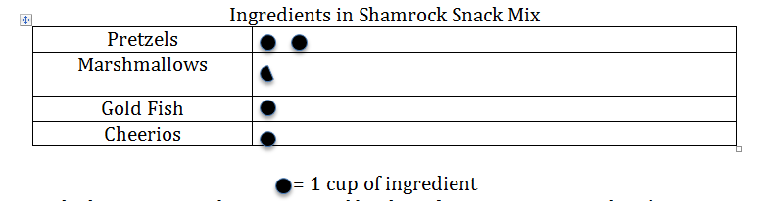
Which statement is best supported by the information presented in the pictograph?
A. There are a total of 5 cups of ingredients
B. The ratio of the amount of cheerios to the amount of pretzels is 2 to 1
C. The difference between the amount of cheerios in the mix and marshmallows is 1 cup.
D. The ratio of the amount of Gold Fish to Pretzels is 1 to 2.
4. While making lemonade Scott realizes his lemonade is extremely sweet. He looks back at the ingredients and realizes the ratio of water to sugar was 3 to 2. What could Scott have accidentally done to make the lemonade so sweet?
_______________________________________________________________________________________________________________________________________________________________________________________________________________________________________

