

Clothes

Jeans $40.00

T‐shirt $10.50

**GOING SHOPPING**

Candy Bar

$1.25

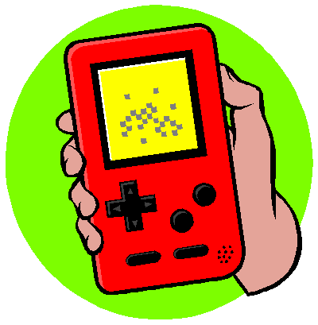

Purse

$10.00

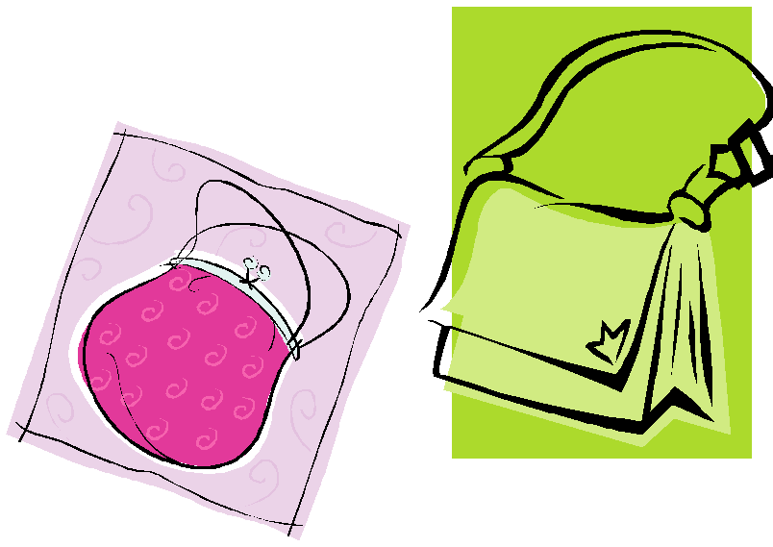

PSP $169.99

Nintendo DS $129



Movie

$6.50

Popcorn Package

$5.25

Chips

$1.50



iTunes

$10.00

10 songs





Bike: $89.99

$89.99



Wireless Control: $39.99

Video Game:

$27.99



Pizza

Large $12.00

Medium $9.50

Small $6.25