Cylindrical Steve

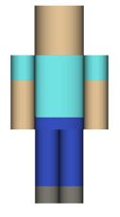

Body  Part | Dimensions | Volume | Lateral Surface Area | Total  Surface  Area
 | Formula:
Head | Radius: 5 units  Height: 8 units
Body | Radius: 5 units  Height: 12 units
Leg 1 | Radius: 2 units  Height: 12 units
Leg 2 | Radius: 2 units  Height: 12 units
Arm 1 | Radius: 2 units  Height: 12 units
Arm 2 | Radius: 2 units  Height: 12 units
Total:

