Name___________________
Ocean Currents Student Lab Sheet
Part One: Understanding Oceans
- Fill your container with tap water.
- Put blue food coloring in a cup of ice water.
- Fill a syringe with the ice water and empty it carefully at each end of the container.
Observation:

----------------------------------------------------------------------------------------------------------------------------------------------------------------------------------------------------------------------------------------------------------------------------------------------------------------------------------------------------------------------------------------------------------------------------------
4) What does the blue water represent? ________________________________________
- Why was it placed at the far end of your container?__________________________
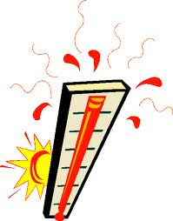
PART TWO: Beat the Heat
- Use the syringe to carefully put several drops of red hot water at the bottom of the middle of the container.
- Remove the syringe and watch what happens to the red water.
Observation:
------------------------------------------------------------------------------------------------------------------------------------------------------------------------------------------------------------------------------------------------------------------------------------------------------------------------------------------------------------------------------------------------------------------------------------------------------
- Why is it important to study ocean currents? How do plants, animals, and humans use ocean currents?_________________________________________________________
___________________________________________________________________________

