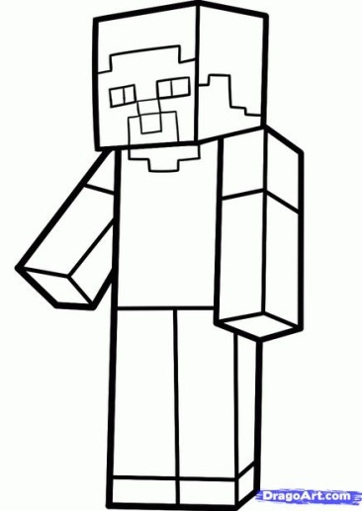

**MATH**

Name___________________________

**STEP ONE**: Watch the video of Steve doing the **Happy Dance**. Pay attention to what solid shapes his arms, legs, body, and head are.

1. What part of Steve’s body is a cube?___________
2. What is the volume of that cube? _________ cubic units
3. What parts of Steve’s body are rectangular prisms? ________________________
4. What is the volume of Steve’s arms? _______cubic units
5. What is Steve’s **TOTAL** volume? _______ cubic units

**STEP TWO**: **MAKING STEVE’S HEAD FROM CUBES**

1. Steve’s head has grown. It now has a volume of 64 cubic units. Make Steve’s head!
2. What is the length, the width and the height of Steve’s head?_______ units.
3. How many faces are there on Steve’s head?______
4. How many edges are there on Steve’s head?______
5. What is the area of each face?______ square units
6. What is the perimeter of each face?______ units

**STEP THREE**: **MAKING STEVE’S CHEST FROM CUBES**

1. Steve’s chest has a new volume of 64 cubic units. Make Steve’s chest!
2. What is the length of Steve’s chest?____ units
3. What is the width of Steve’s chest? ____ units
4. What is the height of Steve’s chest? ____ units
5. How many vertices are there on Steve’s chest?______
6. What is the area of the biggest face?______ square units
7. What is the perimeter of the smallest face?______ units

**STEP FOUR**: **PUTTING IT ALL TOGETHER…TIME FOR SOME FORMULAS**

1. How many **congruent** **faces** are on Steve’s head? ______
2. What formula would we use to calculate the volume of Steve’s head?
3. What shape is Steve’s chest? ____________ ___________________
4. What formula would we use to calculate the volume of Steve’s chest:
5. Which part of Steve’s body is a **regular solid**?___________

**STEP FIVE: CHALLENGE TIME**

1. You are building a fort that has exactly 80 cubic units and is a **rectangular prism**. Design the fort and tell what its dimension are:

Length:____ units Width: _____ units Height:______units

1. You are building a fort that has exactly 125 cubic units and is a **regular solid**. Design the fort and tell what its dimension are:

Length:____ units Width: _____ units Height:______units