Name______________________________ **GRAPHING EVALUATION QUESTIONS**

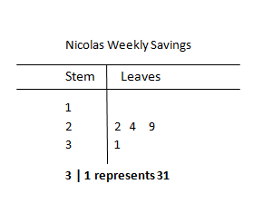

1) Nicolas is saving his weekly chore money to buy a new bicycle. The amount of money Nicolas saved each week in dollars is 12, 24, 15, 22, 29, 10, 12, 11, 14, 31, and 16.

Nicolas is making a stem-and-leaf plot of the data. What are the leaves for stem 1?

**A. 0, 1, 2, 2, 4, 5, 6**

**B. 1, 2, 4, 5, 6**

**C. 0, 1, 2, 4, 5, 6**

**D. 1, 2, 4, 9**

2) For how many weeks was Nicolas’ savings more than $20?

A. 3

B. 4



C. 5

D. 11

3) Which statement is best supported by the information in the

stem-and-leaf plot on the right?

**A** 1/2 of the visitors were 40 or older.

**B** Twice as many visitors were in their 40s than in their 20s.

**C** 1/4of the visitors were in their 50s.

**D** 1/8 of the visitors were younger than 40.

4) Ms. Hernandez’s fifth grade science club had a bake sale where they sold 625 cookies. The number of cookies eight of the students sold is represented on the line plot above.

If the other two members sold an equal number of cookies, how many cookies did each one sell?

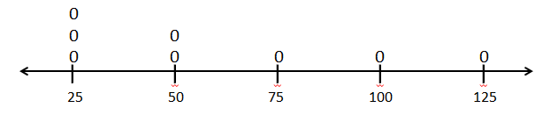

5) Below is a dot plot showing the age of people that ate lunch at McDonalds. What is the difference of the total of people over 25 and the total under 25?

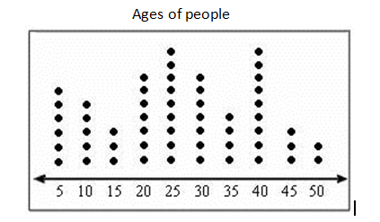

**A** There are four less people over 25 than under 25.

**B** There are four more people over 25 than under 25.

**C** There are thirteen more people over 25 than under 25.

**D** There are equal numbers of people over 25 than under 25.