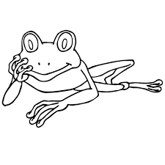 Name:___________________________
The Rainforest
- How can mining for gold in the rainforest affect its ecosystem?

- How do poachers affect the food webs of animals in the rainforest?

3.What does the article say could happen by removing just one plant or animal from the rainforest? Why do you think that is? (Hint: Think food webs!)

Coral Reef
Name FIVE Practices that
HURT the Coral Reef
Name FIVE Practices that
HELP the Coral Reef

Coal Mining
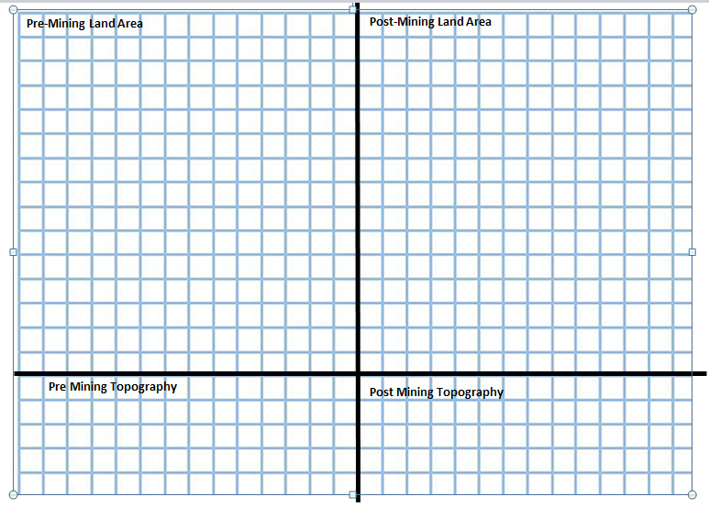

Port City of Corpus Christi
- What are three things that humans are doing here in Corpus Christi that are negatively impacting our ecosystem?

- What are three things that YOU can do to positively impact your environment?

