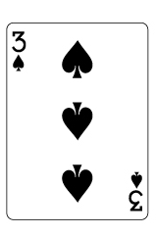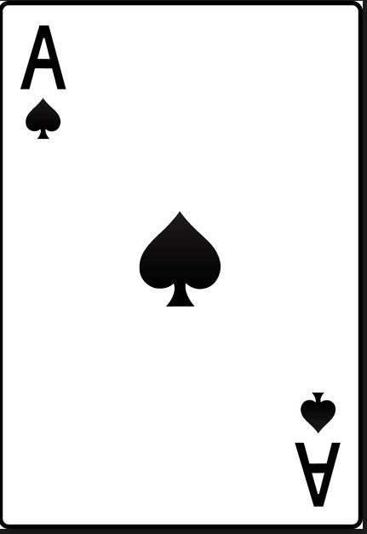
I CAN MAKE PRIME NUMBERS
I can make 2________________________
Directions:
- Each two people will receive one game board and one deck of cards. Two people make a team.
- Each team will divide the deck of cards evenly.
- Each team will challenge two other people to a game.
- Each person on the team will turn over one card. The team will try to make as many prime numbers as they can with their two cards. They will try to create a prime number by using the two cards as a two digit number, multiplying the two cards, adding the two cards, subtracting the two cards, or dividing the two cards.
- As they make a prime number, the team will record what number they make and how they made it on this page.
- The winning team is the team that completes their card, making all the prime numbers up to 100.
I can make 3________________________
I can make 5________________________
I can make 7________________________
I can make 11________________________
I can make 13________________________
I can make 17________________________
I can make 19________________________
I can make 23________________________
I can make 29________________________
I can make 31________________________
I can make 37________________________
I can make 41________________________
I can make 43________________________
I can make 47________________________
I can make 53________________________
I can make 59________________________
I can make 61________________________
I can make 67________________________
I can make 71________________________
I can make 73________________________
I can make 83________________________
I can make 89________________________
I can make 97________________________

