Understanding Energy, Force, and Motion 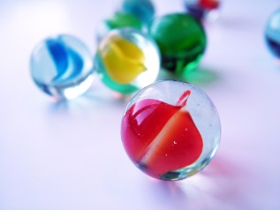
- After participating in the group activity directed by your teacher, relate the motion of the ball to the motion of the marble traveling around the lip of the petri dish and the plate. How are the two alike? How are the two different?
______________________________________________________________________________________________________________________________________________________________________________________________________________________________________________________________________________________________________________________________________________________________________________________________________________________________________________________________________________________________________________________________________

- During the time the ball was in motion, what were the forces acting on it?
________________________________________________________________________________________________________________________________________________________________________________________________________________

- When the ball came to rest on the floor, what were the forces acting on it?
________________________________________________________________________________________________________________________________________________________________________________________________________________

- When more than one force acts on an object, the net force is the sum of the forces. What was the net force acting on the ball when it was resting on the floor?
________________________________________________________________________________________________________________________________________________________________________________________________________________

- When the force acting on an object is zero, the object is in a state of equilibrium. Give some examples of an object that is in equilibrium.
________________________________________________________________________________________________________________________________________________________________________________________________________________

