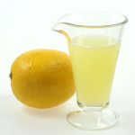

Lemon Juice and Water
- Add a tablespoon of lemon juice to the glass.
- Stir the water.
- Try to separate the lemon juice and water.

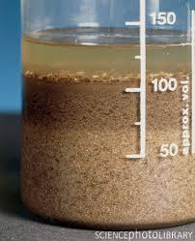
Sand and Water
- Add sand to the glass.
- Stir the water.
- Try to separate the sand and water.

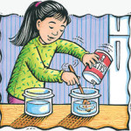
Salt and Water
- Add a tablespoon of salt to the glass.
- Stir the water.
- Try to separate the salt and water.

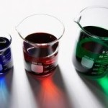
Kool Aid and Water
- Add a tablespoon of kool aid to the glass.
- Stir the water.
- Try to separate the kool aid and water.

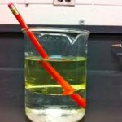
Oil and Water
- Add a ¼ cup of oil to the glass.
- Stir the water.
- Try to separate the oil and water.

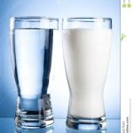
Milk and Water
- Add a tablespoon of milk to the glass.
- Stir the water.
- Try to separate the milk and water.

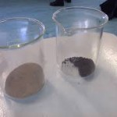
Iron washers and Sand
- Add the iron washers to the sand.
- Stir the sand.
- Try to separate the iron washers and sand.

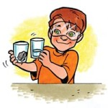
Rocks and Water
- Add rocks to the glass.
- Stir the water.
- Try to separate the rocks and water.

