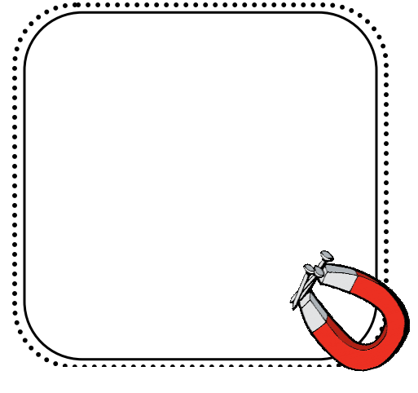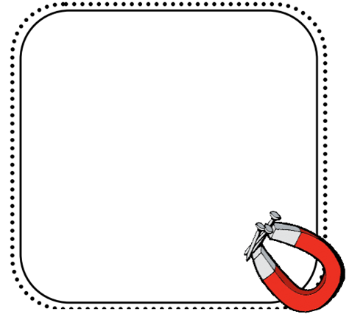

**WRITE**

**About the properties of magnets and how they can be useful in our lives.**

**THINK**

**When do you and people you know use magnets in their lives?**

