Name_________________________

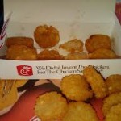
Hungry for Hash Browns?

An order of hash browns is $.95
- How much would two orders of hash browns cost?

- How much would five orders of hash browns cost?

- How much would ten orders of hash browns cost?

- How much would twelve orders of hash browns cost?

