Name______________________

PRACTICE WITH DISTANCE, SPEED, TIME

Directions: For each problem, write the formula, plug in the number with units, and write the answer with the correct units. If the answer has decimal points, round off to the nearest hundredth.

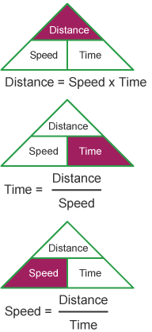

1. A train travels at a speed of 30 miles per hour and travels a distance of 240 miles. How long did it take the train to complete its journey?

2. A cyclist travels 25 kilometers in 4 hours. What is the cyclist speed?

3. How long does it take to drive a distance of 260 miles at a speed of 65 miles per hour?

4. If you shout into the Grand Canyon, your voice travels at the speed of sound, at 340 meters/second. If it takes 5 seconds to hear your echo, how far did sound travel?

5. How much time will it take a spider to travel 15 meters across the floor if it is traveling at 0.05 meter/second?

6. The distance between two cities is 144 kilometers. It takes 3 hours for a car to travel between the two cities. What is the average speed of the car

7. At 8:14 am, a football player was standing at the 25 meter mark on the field. He was training and had to move a 400 pound object from one distance to another. At 8:39 am, he was now at 125 meter mark on the filed. Show your work!
A. How far did he move?

B. How long did it take for him to move to the 125 meter mark?

C. How fast did he move?

8. It took Jenny 3.5 hours to drive from her home to Huntington Beach moving at a speed of 60.5 kilometers per hour. What distance did she travel from her house to Huntington Beach? Show your work step by step and explain each step.
Show the math work step by step. | Explain your steps using complete sentences.

