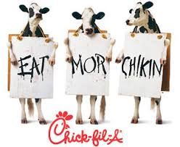
Chick-fil-A Challenge

Situation: You and three friends have spent the day at the beach and are going to Chick-fil-A on the way home. You are very hungry! You have $30. Each of you are ordering at least one drink, one dessert, and one main dish. If you order a meal, that would count as a main dish and a drink. Your goal is to spend as close to $30 without going over. Assume that tax is included.
STEP ONE: Plan your order.
STEP TWO: On scratch paper (you may use the back of this paper), calculate how much your order is going to cost.
STEP THREE: Make adjustments to try to reach the goal to get as close to $30 without going over. Write out your final purchase in the table below.
Name of item | Cost of item | Number of this item purchased | Total cost for this item
FINAL TOTAL:

