Name_______________
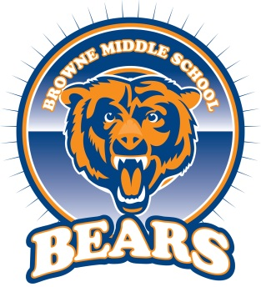
Bears Snack Mix
Recipe for Bears Snack Mix:
½ cup of cheerios
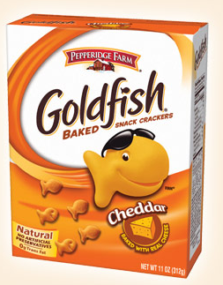
2/3 cup of goldfish
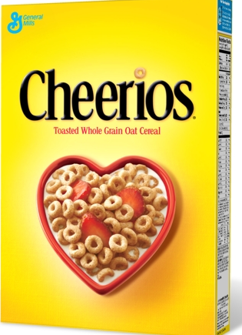
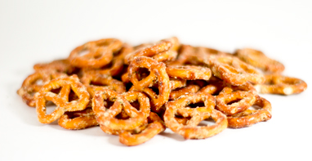
¼ cup of raisins
¾ cup of pretzels

STEP ONE: Measure all your ingredients into a bowl.
STEP TWO: List the ingredients in order from the one that you have the least of to the one that you have the greatest amount of.

STEP THREE: How many cups of snack mix do you make if you follow this original recipe? Use the picture below to help you.
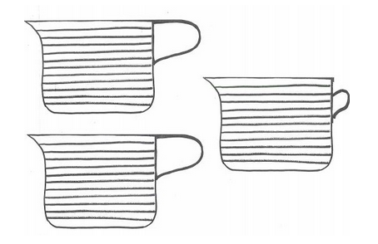

STEP FOUR: How much more pretzels do you have than goldfish?

STEP FIVE: It’s time to DOUBLE THE RECIPE. Write how much of each ingredient you would need if you wanted to make twice as much snack mix.

______ cup of cheerios
______cups of goldfish
______cup of raisins
______cups of pretzels

TOTAL CUPS OF SNACK MIX:

STEP SIX: You need to share the snack mix equally, so that each member of your group gets the same amount. How would you do this? How much would each person get?
_____________________________________________________________________________________________________________________________________________________________________________________________________________________________________________________________________________________________________________________________________________________________________________________________________________________

STEP EIGHT: TIME TO EAT!

CHALLENGE: What if you needed to make enough Bears Snack Mix for the entire school? What information would you need to know in order to figure out how much you need of each ingredient?

