Name________________________
Trait Checklist: Do You Have the Following Traits?
Trait | Example | Yes | No
Attached Earlobe | 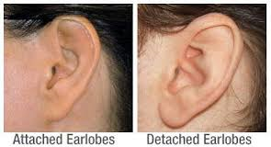
Hitchhiker’s Thumb | 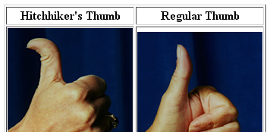
Widow’s Peak | 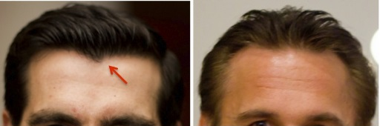
Freckles | 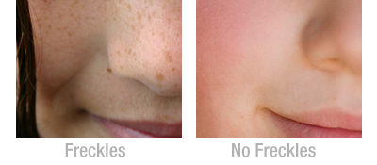
Roll Tongue | 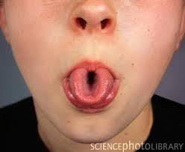
Dimples | 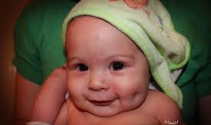
Right-handed | 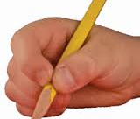
Clasp Hands :  Left over right thumb? | 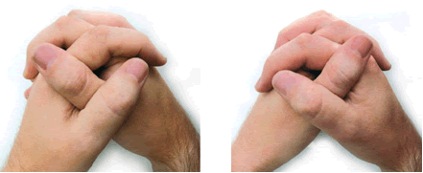
Fold Arms:  Left on top of right? | 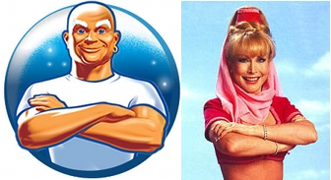
Cleft Chin | 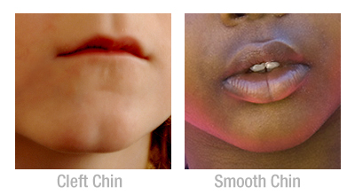

GENETICS NOTES

: passing characteristics from parent to offspring
: branch of biology devoted to the study of heredity
: segment of DNA or hereditary unit
The “Father of Genetics” was _________________________________
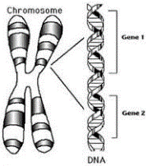
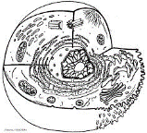
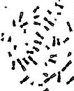

Mendel’s Theory of Heredity
- For every trait there are _______ copies of the gene (one from each parent)
- There are alternative versions of the gene (_________________)
- When two different alleles are present, one is expressed (____________)while the other is not visible (__________________)
By looking at an individuals alleles, we can describe their
__________________: genetic makeup
__________________: what they look like
If two alleles code for the same characteristic they are ________________________.
TT = ___________________dominant
tt = ___________________ recessive
If the alleles are different they are ___________________.
Tt = heterozygous
Practice: For each genotype below, indicate whether it is heterozygous (He) or homozygous (Ho).

____RR
____Rr
____TT
____pp
Determine the phenotype for each genotype using the information provided
Round head is dominant over oval head
RR _____________________ Rr ______________________ rr ____________________

____ll ____Hh
____ss ____BB
____Tt ____Nn
____aa ____Ll

